­­­Research data:

Finding homologs between sequences for chr8 700,001..795,000

Chr8 sequence Annotations

Annotation: chr8

PASTE CODING REGION HERE:­­



[chr8:49455025-49458016 - strand] [peptide]

IsoSeq Top Tier Results

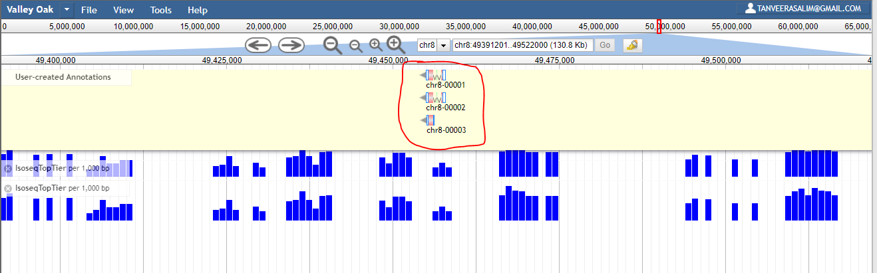

IsoSeq Top Tier Results Close-Up

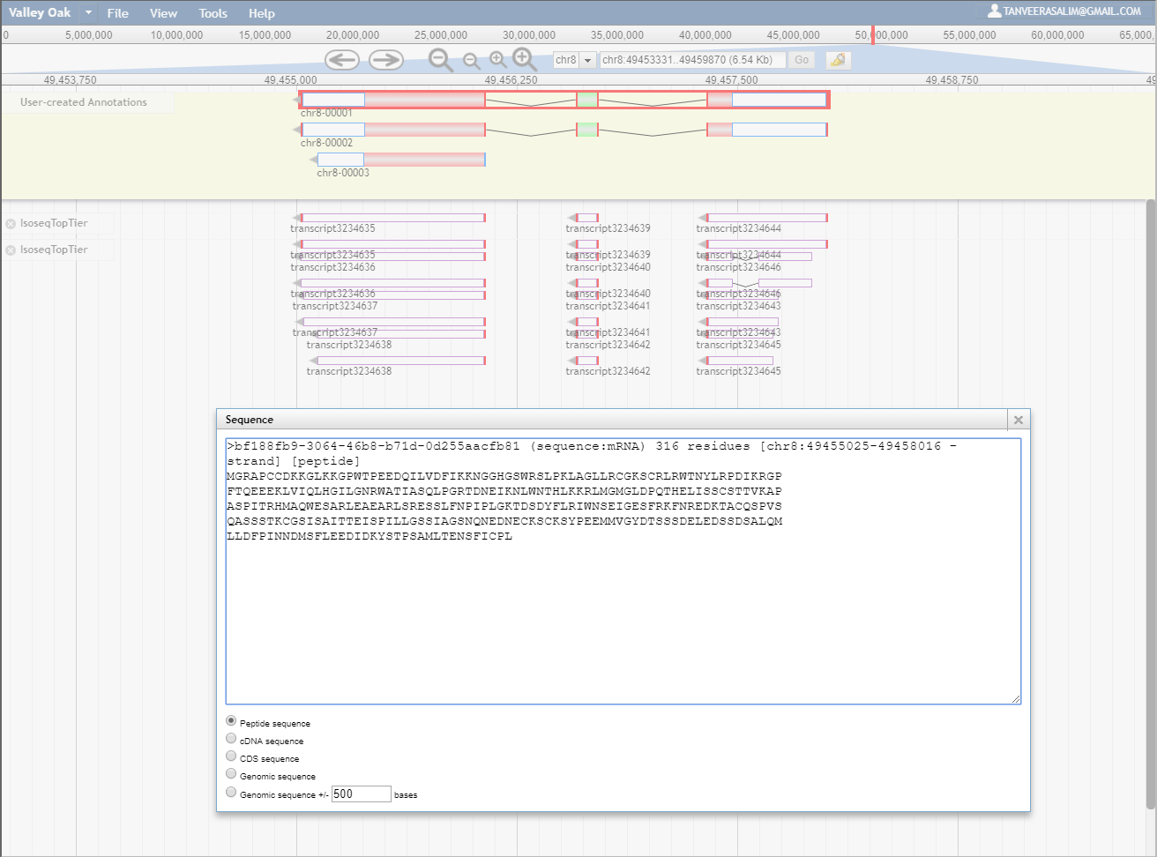

Peptide Sequences being Compared:

>bf188fb9-3064-46b8-b71d-0d255aacfb81 (sequence:mRNA) 316 residues [chr8:49455025-49458016 - strand] [peptide]

MGRAPCCDKKGLKKGPWTPEEDQILVDFIKKNGGHGSWRSLPKLAGLLRCGKSCRLRWTNYLRPDIKRGP

FTQEEEKLVIQLHGILGNRWATIASQLPGRTDNEIKNLWNTHLKKRLMGMGLDPQTHELISSCSTTVKAP

ASPITRHMAQWESARLEAEARLSRESSLFNPIPLGKTDSDYFLRIWNSEIGESFRKFNREDKTACQSPVS

QASSSTKCGSISAITTEISPILLGSSIAGSNQNEDNECKSCKSYPEEMMVGYDTSSSDELEDSSDSALQM

LLDFPINNDMSFLEEDIDKYSTPSAMLTENSFICPL

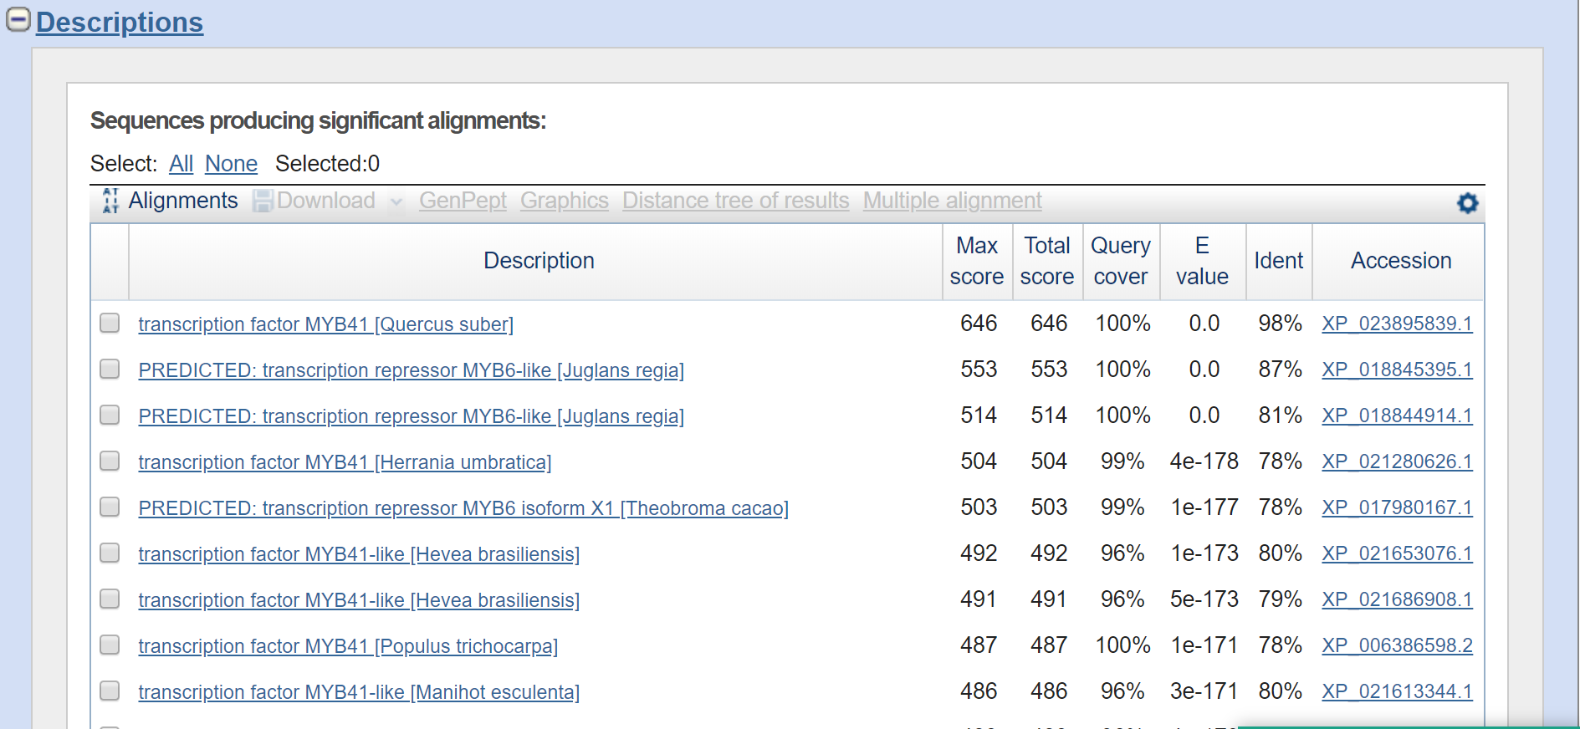

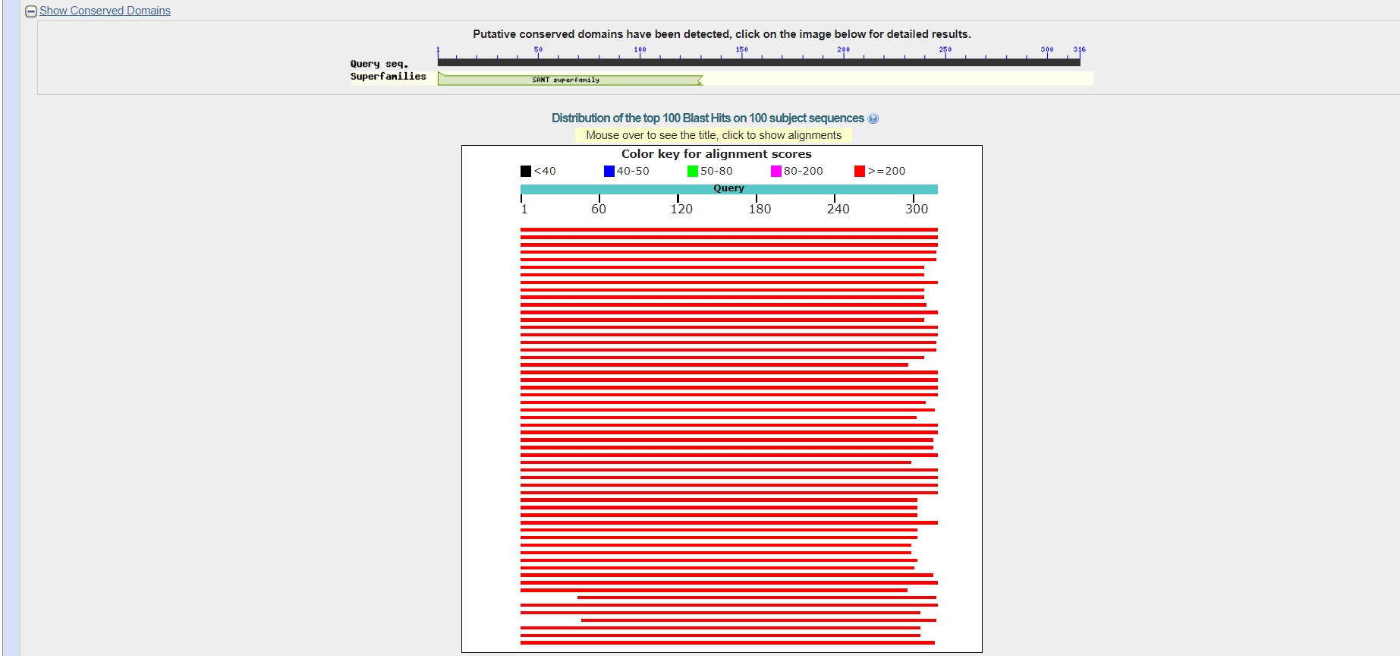

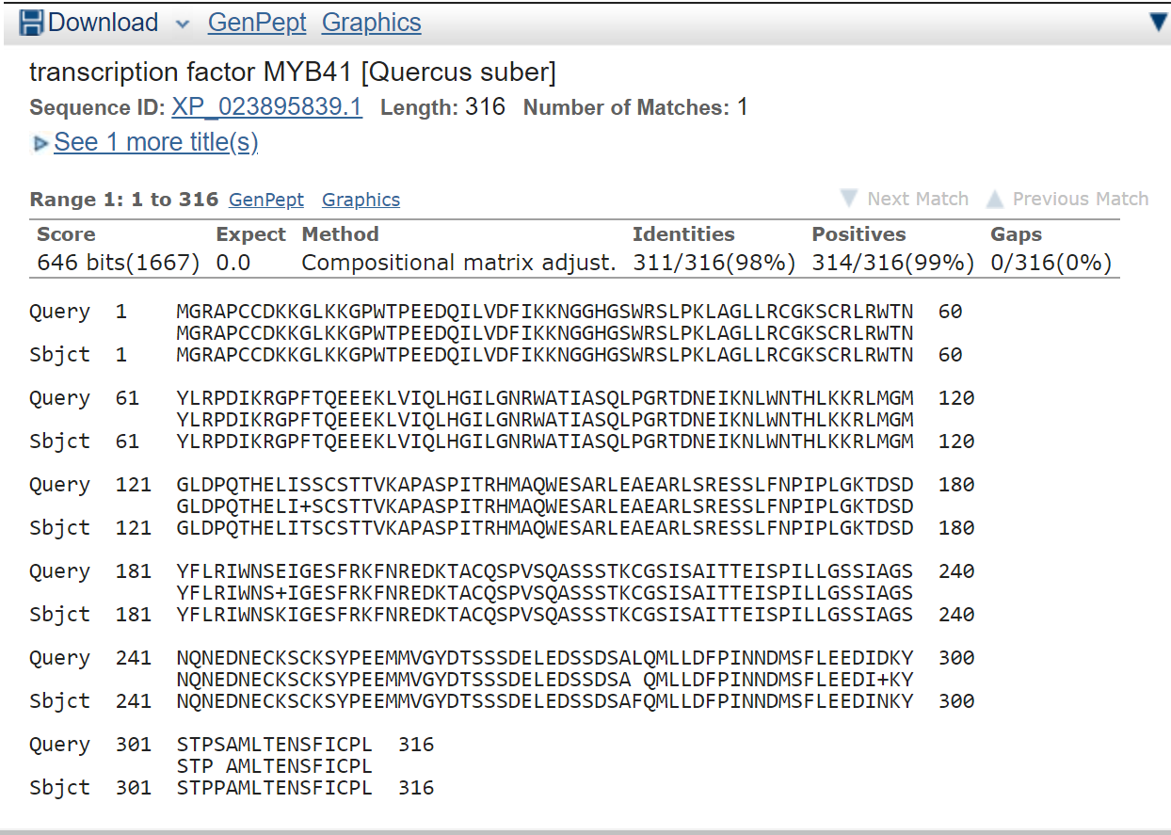

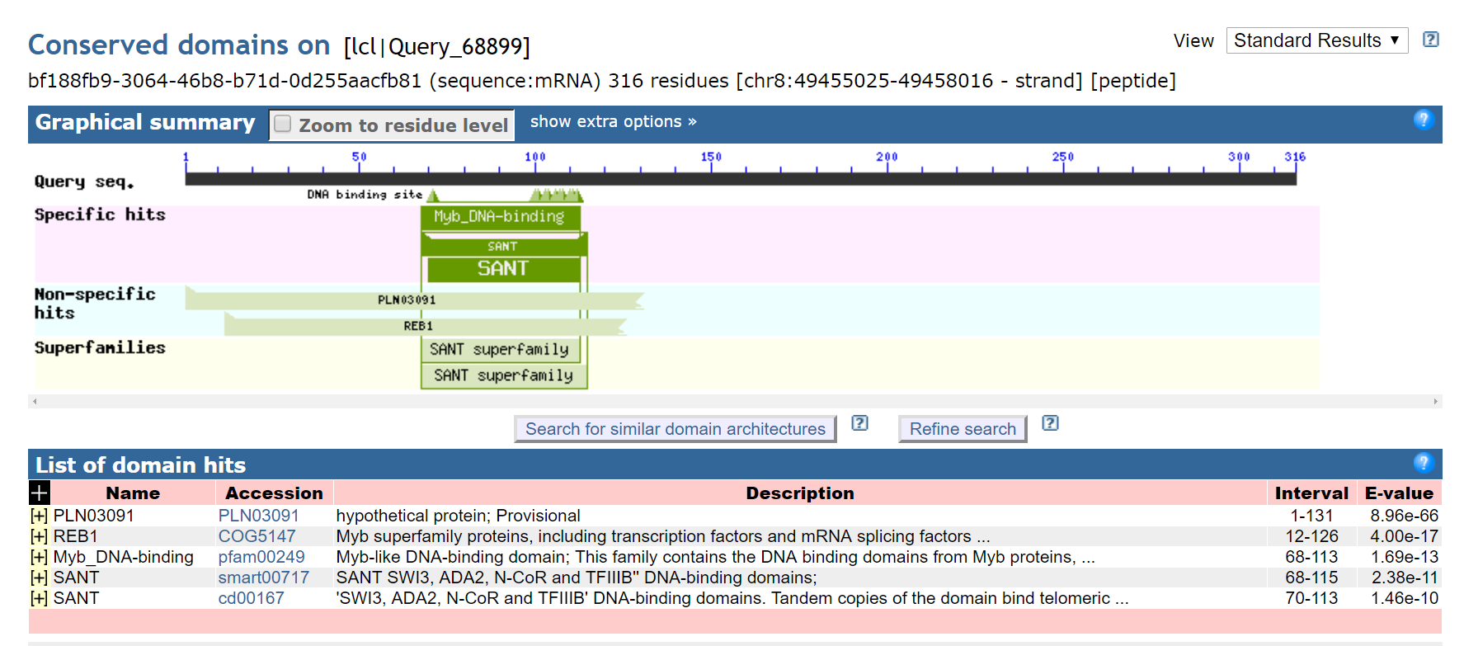

-----------------------------------------------------------------------------------------------------------------------------------

**transcription factor MYB41 [Quercus suber]**

**NCBI Reference Sequence: XP_023895839.1**

>XP_023895839.1 transcription factor MYB41 [Quercus suber]

MGRAPCCDKKGLKKGPWTPEEDQILVDFIKKNGGHGSWRSLPKLAGLLRCGKSCRLRWTNYLRPDIKRGP

FTQEEEKLVIQLHGILGNRWATIASQLPGRTDNEIKNLWNTHLKKRLMGMGLDPQTHELITSCSTTVKAP

ASPITRHMAQWESARLEAEARLSRESSLFNPIPLGKTDSDYFLRIWNSKIGESFRKFNREDKTACQSPVS

QASSSTKCGSISAITTEISPILLGSSIAGSNQNEDNECKSCKSYPEEMMVGYDTSSSDELEDSSDSAFQM

LLDFPINNDMSFLEEDINKYSTPPAMLTENSFICPL

# PREDICTED: transcription repressor MYB6-like [Juglans regia]

NCBI Reference Sequence: XP_018845395.1

>XP_018845395.1 PREDICTED: transcription repressor MYB6-like [Juglans regia]

MGRAPCCDKRGLKKGPWTPEEDEILVEYIKKNGGHGSWRSLPKLAGLLRCGKSCRLRWTNYLRPDIKRGP

FTQEEEKLVVQLHGILGNRWASIAAQLPGRTDNEIKNLWNTHLKKRLVCMGLDPQTHEPVNSCSTTIKAP

ASPTTRHMAQWESARLEAEARLSRESSLFHPNPVGGTDSDYFLRIWNSEVGESFRKFSMGDKTLCQSPVS

QASSSTKCGSMSAITTEICPILGGSSIAGSNQNEDTECKSCKSYTEEMMAASDCSSSDELEDSSENALQL

LLDFPINNDMSFLEEDLDMYALPPAMLTESSFICHL

# transcription factor MYB41 [Herrania umbratica]

NCBI Reference Sequence: XP_021280626.1

>XP_021280626.1 transcription factor MYB41 [Herrania umbratica]

MGRTPCCDRKGLKKGPWAPEEDEILVNYIKKHGHGSWRSLPKLAGLLRCGKSCRLRWTNYLRPDIKRGPF

TLEEEKLVIQLHGILGNRWAAIASQLPGRTDNEIKNLWNTHLKKRLVCMGLDPQTHEPFTPCGPTTAAPT

SPATRHMAQWESARLEAEARLSRESLLFSSPPLGKPDSDYFLRLWNSEVGESFRKLNREDKTACQSPISQ

ASSSTKCGSVSAVTIDICPNIAGSSTPASNQIEDTACKSFKSCTEDPVDASDSSCSNESEDSSDTALQLL

LDFPINNDMSFLENVDAYATSAAMLTDTSFISPSEGYLKA

# PREDICTED: transcription repressor MYB6 isoform X1 [Theobroma cacao]

NCBI Reference Sequence: XP_017980167.1

[GenPept](https://www.ncbi.nlm.nih.gov/protein/XP_017980167.1?report=genpept) [Identical Proteins](https://www.ncbi.nlm.nih.gov/ipg/XP_017980167.1) [Graphics](https://www.ncbi.nlm.nih.gov/protein/XP_017980167.1?report=graph)

>XP_017980167.1 PREDICTED: transcription repressor MYB6 isoform X1 [Theobroma cacao]

MGRTPCCDRKGLKKGPWAPEEDEILVNYIKKHGHGSWRSLPKLAGLLRCGKSCRLRWTNYLRPDIKRGPF

TLEEEKLVIQLHGILGNRWAAIASQLPGRTDNEIKNLWNTHLKKRLVCMGLDPQTHEPFTPCGPTTAAPT

SPATRHMAQWESARLEAEARLSRESLLFSSPPLGKPDSDYFLRLWNSEVGESFRKLNREDKTACQSPISQ

ASSSTKCGSVSAVTIDICPNIAGSSTPASNQIEDTACKSFKSCTEDPVDASDSSCSNESEDSSDTALQLL

LDFPINNDMSFLENVDTYATSHAMLTDTSFISPSEGYLKA

# transcription factor MYB41-like [Hevea brasiliensis]

NCBI Reference Sequence: XP_021653076.1

[GenPept](https://www.ncbi.nlm.nih.gov/protein/XP_021653076.1?report=genpept) [Identical Proteins](https://www.ncbi.nlm.nih.gov/ipg/XP_021653076.1) [Graphics](https://www.ncbi.nlm.nih.gov/protein/XP_021653076.1?report=graph)

>XP_021653076.1 transcription factor MYB41-like [Hevea brasiliensis]

MGRTPCCDKKGLKKGPWTPEEDEILVRYINKNGHGSWRSLPKLAGLLRCGKSCRLRWTNYLRPDIKRGPF

TLEEEKLVIQLHGILGNRWAAIASQLPGRTDNEVKNLWNTHLKKRLLCMGLDPQTHEPFTSCGPAIKTPA

SPATRHMAQWESARLEAEARLSRESSLFNPPTPGKTDSDYFLRMWNSEVGESFRKFNRGDKTTCQSPASA

SQASSSTKCGSFSAVTADISPNLAGYSTTASNQNEDTECKSFKSYAEDVNAGSDSSSSVELEDSSDSTLQ

LLLDFPINNDMSFLEENVDSIASYSAMQ

# transcription factor MYB41 [Populus trichocarpa]

NCBI Reference Sequence: XP_006386598.2

[GenPept](https://www.ncbi.nlm.nih.gov/protein/XP_006386598.2?report=genpept) [Identical Proteins](https://www.ncbi.nlm.nih.gov/ipg/XP_006386598.2) [Graphics](https://www.ncbi.nlm.nih.gov/protein/XP_006386598.2?report=graph)

>XP_006386598.2 transcription factor MYB41 [Populus trichocarpa]

MGRTPCCDKKGLKKGPWTPEEDDLLVTYIKKNGHGSWRSLPKLAGLLRCGKSCRLRWTNYLRPDIKRGPF

TLEEEKLVIQLHGILGNRWAAIASQLPGRTDNEIKNLWNTHLKKRLLCLGLDPQTHEPFSSRGPVNKGPA

SPATRHMAQWESARLEAEQRLSRESSLFLPPMVEKIDCDHFLRIWNSEVGESFRRINMGDNKTACQSPVS

QASSSTKCGSISAITADIIPNLSRSPATASNQNEDMEWKSPKSYAEDVLAGSDSSSAELEDLTDSTLQLL

LDFPINNDMSFLDKNIDSYATSSAMLTGPSMICPL

Chr8 Phylogenetic Tree

bf188fb9-3064-46b8-b71d-0d255aacfb81

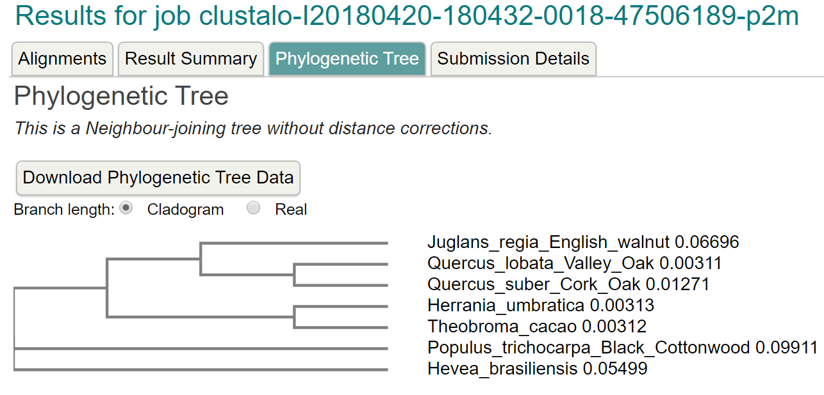

*************************************************************************************

VPVWYNMVNQGLLKEPVFSFWFNRNADEEEGGEIVFGGVDPNHYKGEHTYVPVTQKGYWQFDMGDVMIDG

QTTGFCASGCSAIADSGTSLLVGPTTIITELNHAIGASGIVSQECKTVVAEYGETIIERILAKDQPAKIC

SQIGLCSFDGTHGVSIGIKSVVENTHKVSGDLSDATCSACEMTVVWMQNQLKQNQTQERILDYVNQLCDR

LPSPMGESAVDCAGLSSMPNVSFTIGGRTFDLTPEQYVLKVGEGDAAQCISGFTALDVPPPRGPLWILGD

VFMGRYHTVFDYGNERIGFAEAA

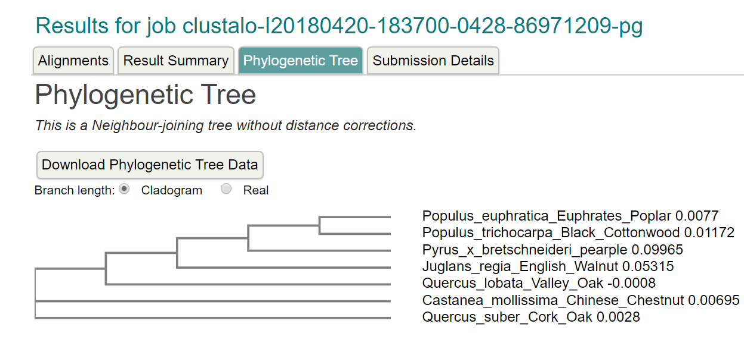

chr8:49455282..49459612 (4.33 Kb): ANNOTATE SEQUENCES WITH YOUR NAME ATTACHED TO IT  
FROM NOW ON

SORRY, all the above WAS NOT

YOUR REGION!

Sorry, all the above WAS NOT EVEN YOUR REGION!

Actual region: chr8h-00004

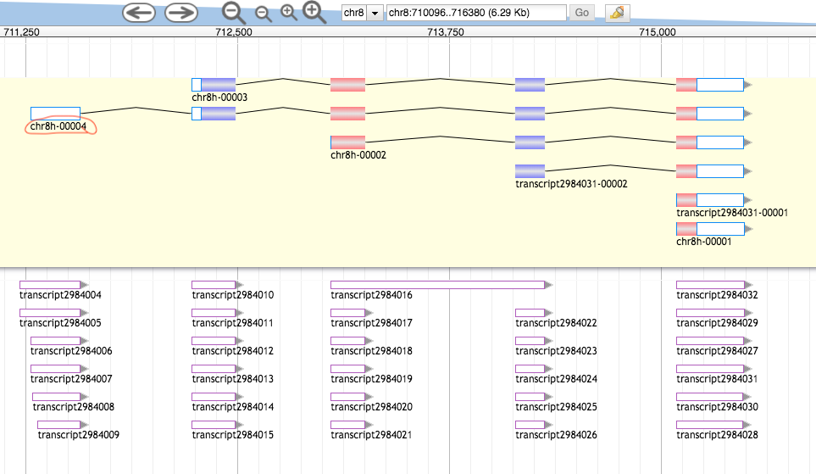



chr8:706211..718780 (12.57 Kb)

Get Peptide Sequence:

>8221e23d-7354-4588-b279-b93bc84e6ad3 (sequence:mRNA) 230 residues [chr8:711279-715487 + strand] [peptide]

MGNKVGKSESPKKVSKPETKLEAKTVEAMKRRAAAGTSMKSFNSIILKFPKIDESLRNCKVIFKQFDEDS

NGAIDYEELKKSFHKLEISCTEEEINDLFQACDINEDKGIDFNEFIVLLCLVYLLKDDAATLHAKARVGM

PDLEATFETLVDAFVFLDKNKDGYVSKSEMVQAINETTSGEGSGQIAMKRFEEMDWDKNGMVNFKEFLFA

FTGWVGIDDNEDEEEGGEK

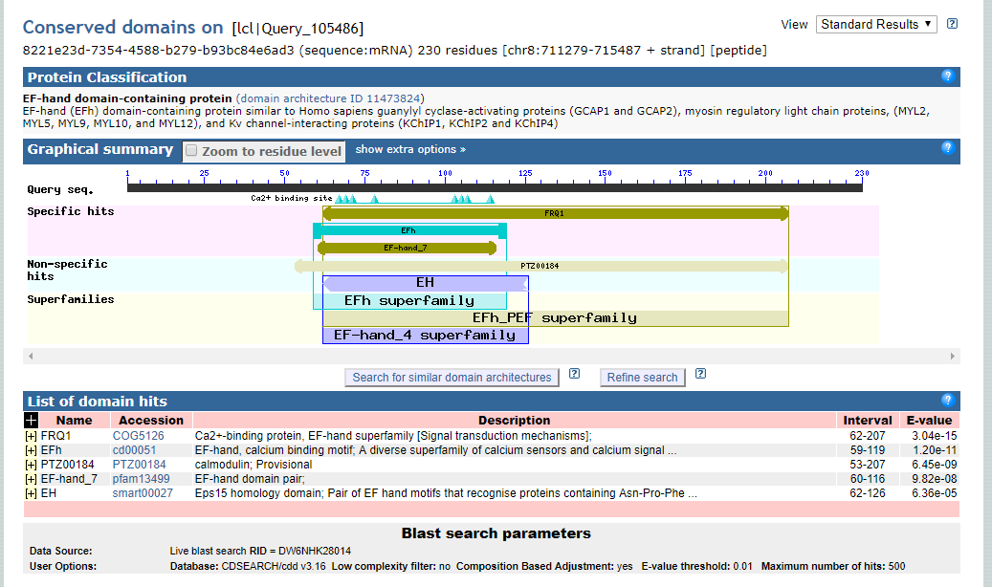

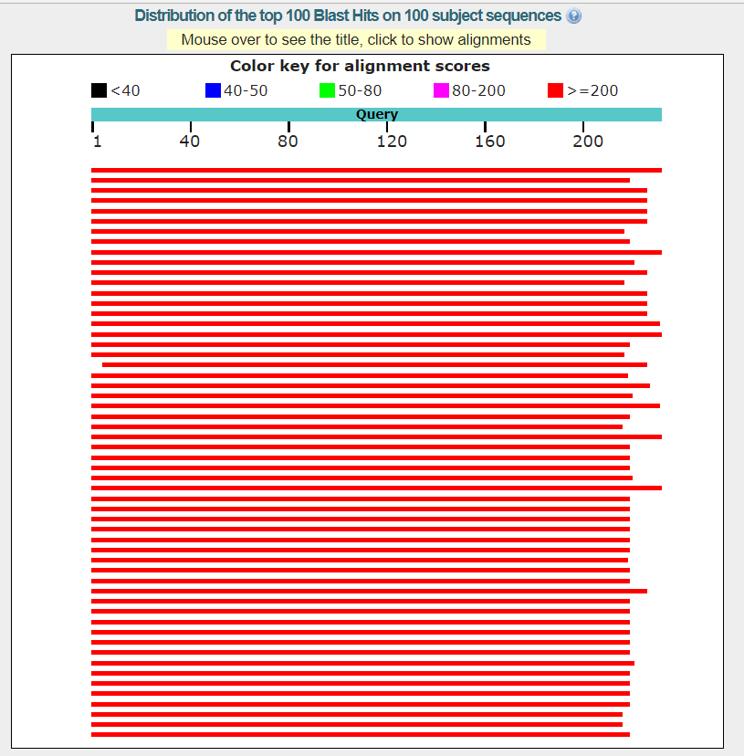

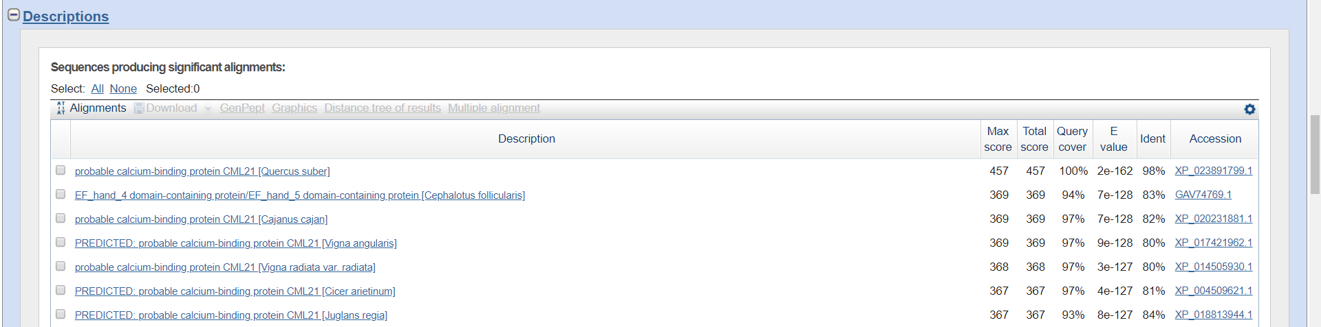

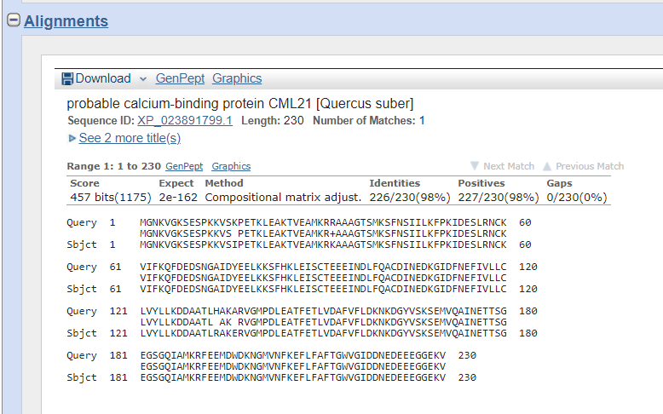

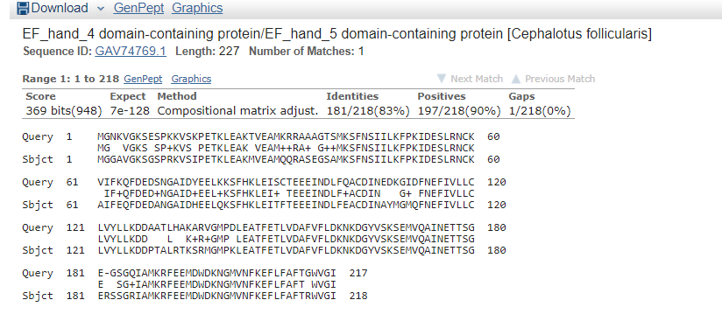

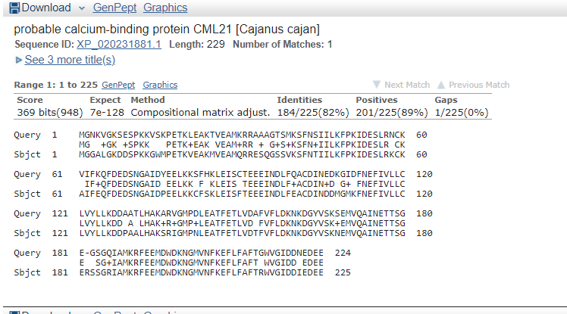

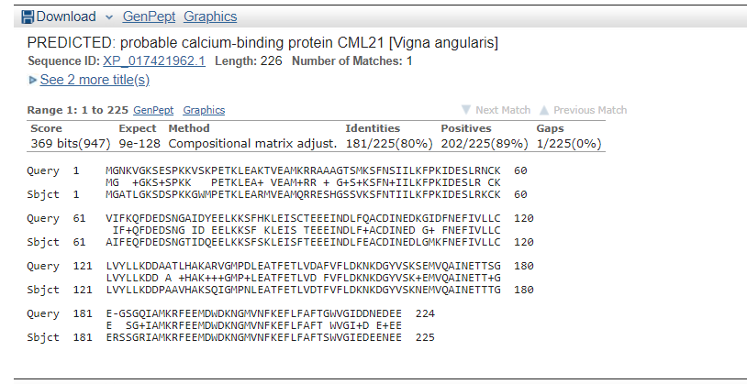

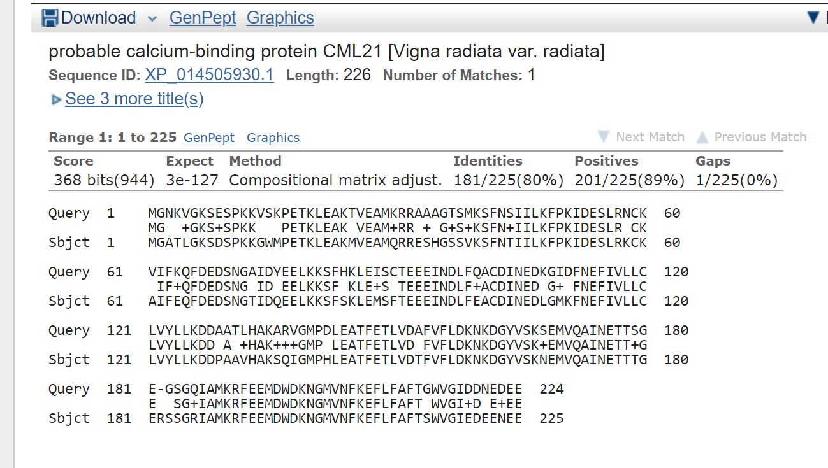

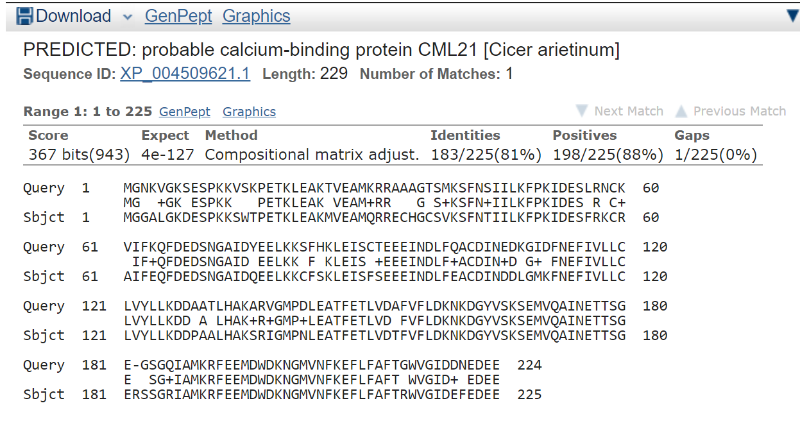

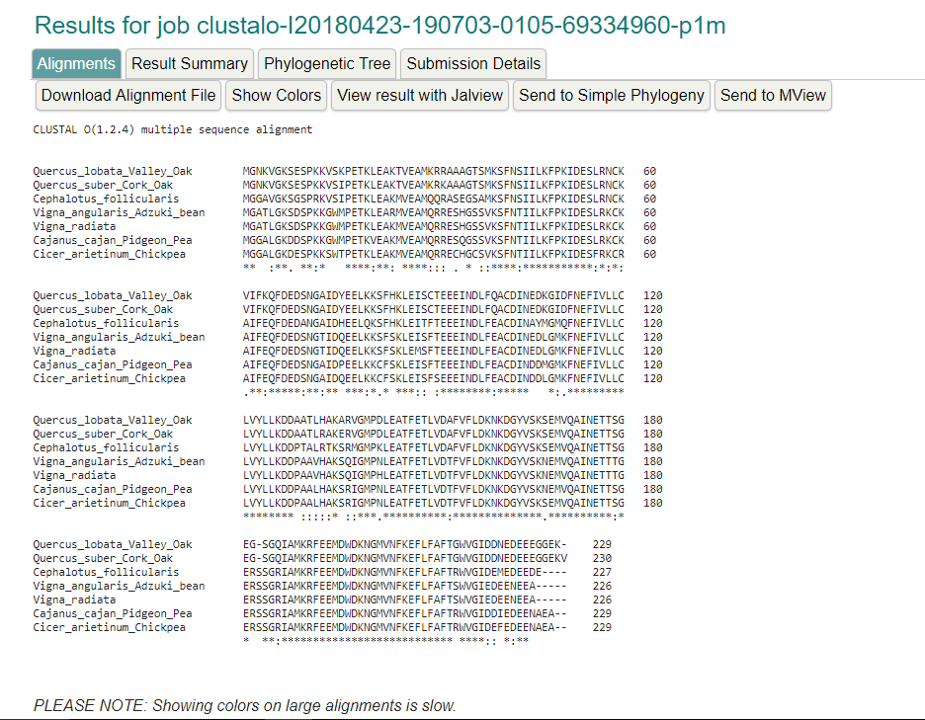

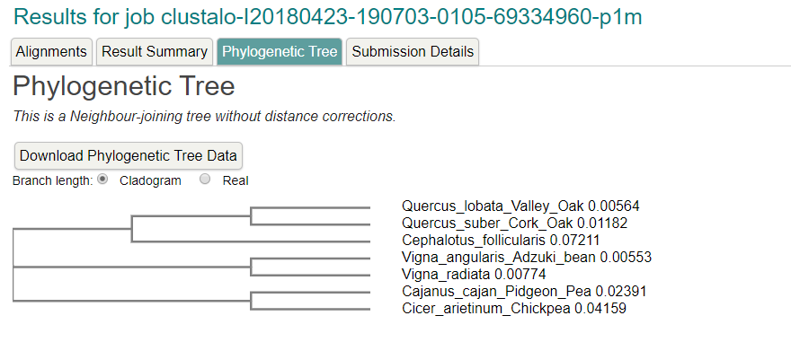

Region: chr8:716586..722870 (6.29 Kb)

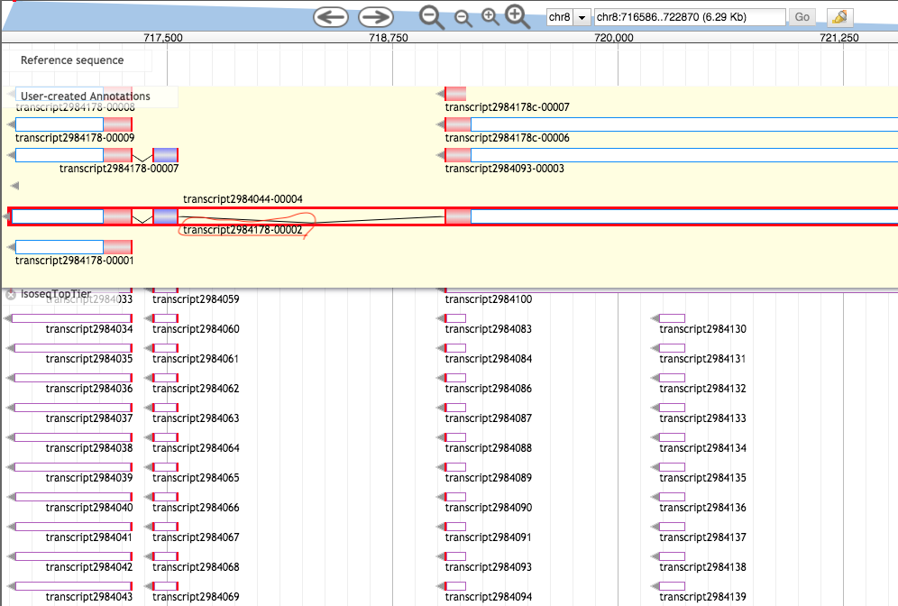

>888593c6-445a-441e-82b5-76e04a4253b9 (sequence:mRNA) 142 residues [chr8:716629-724195 - strand] [peptide]

MLIFIQYNFVGRLLGPRGNSLKRVEASTECRVLIRGRGSIKDPTREEMMRGKPGYEHLNEPLHILVEAEL

PVEIIDARLMQAREILEDLLKPVDETHDFYKKQQLRELAMINGTLREEGSPMSGSVSPFHNSLGMKRAKT

RG

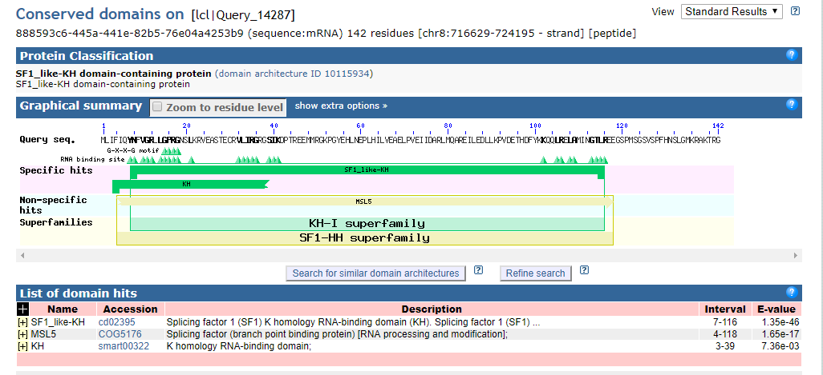

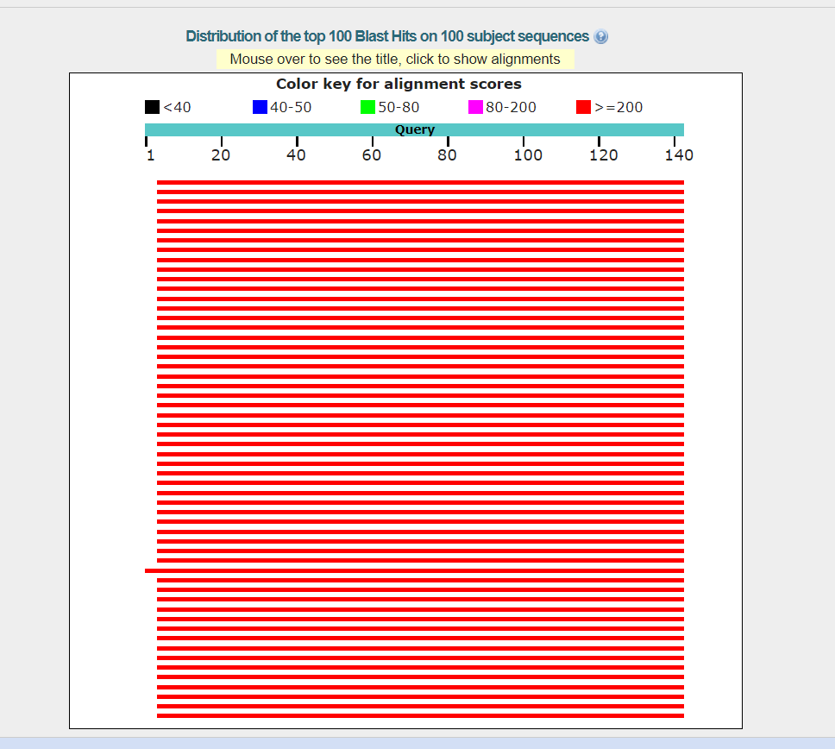

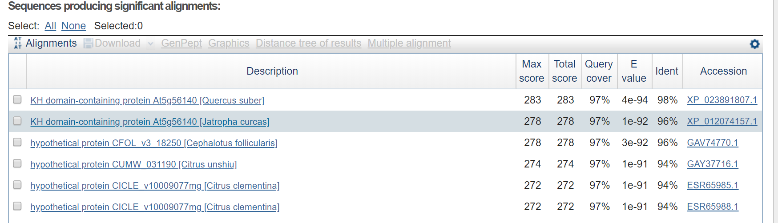

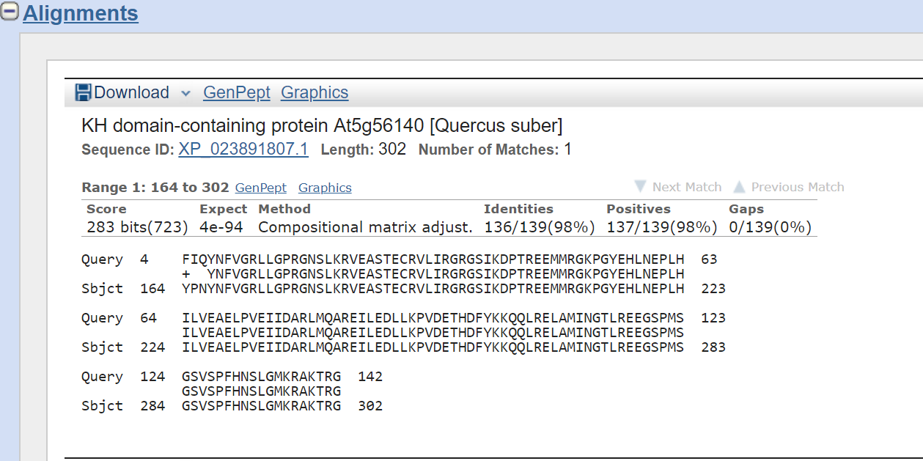

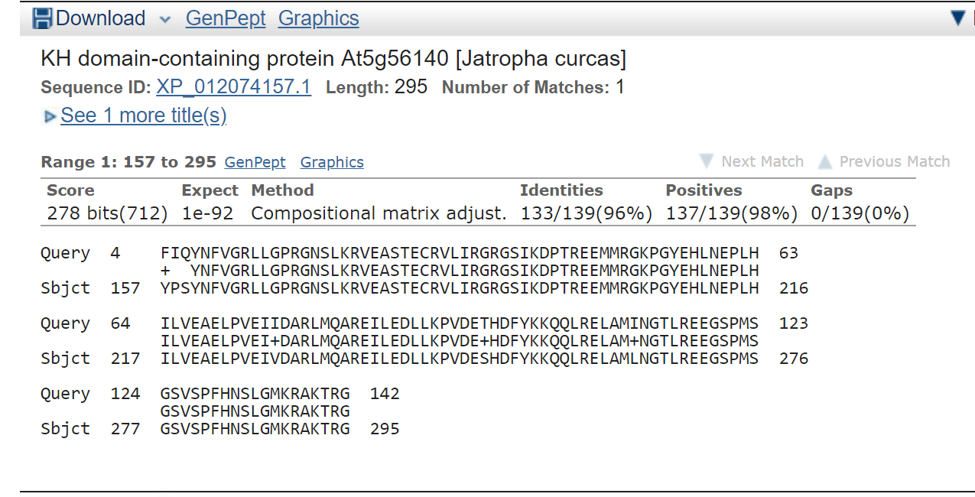

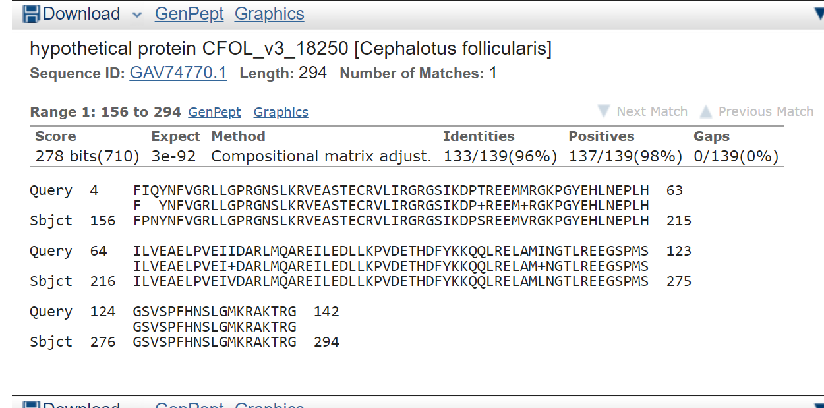

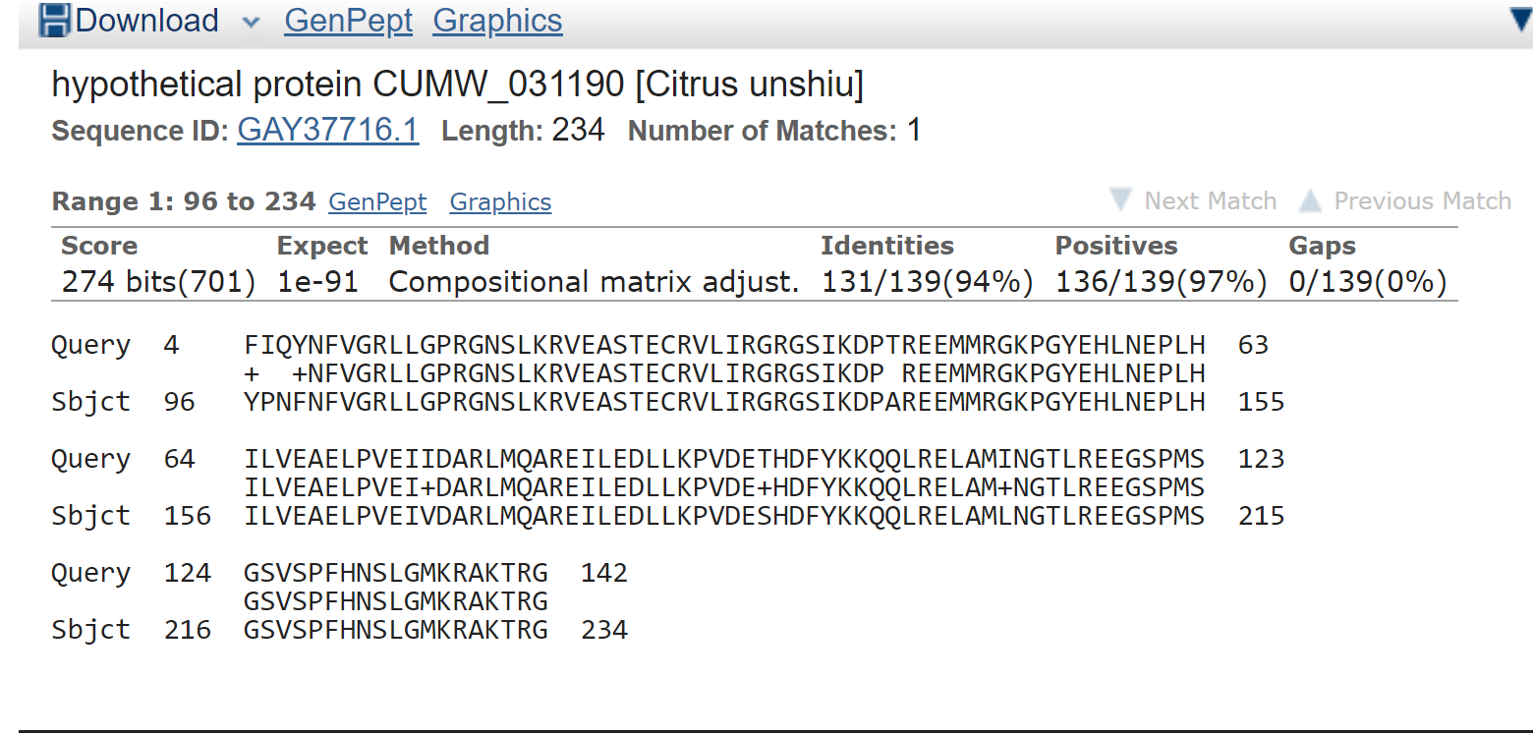

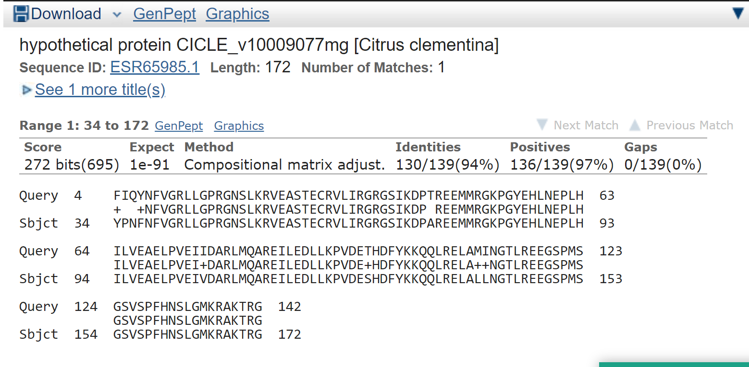

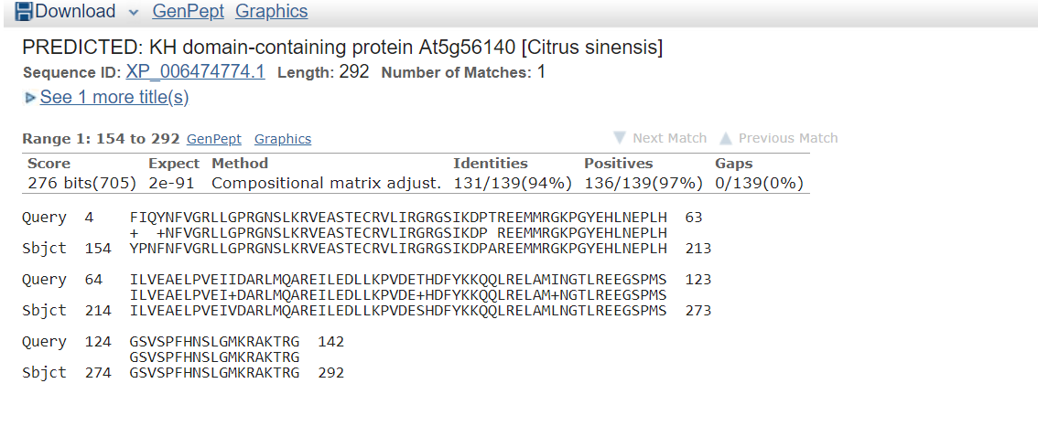

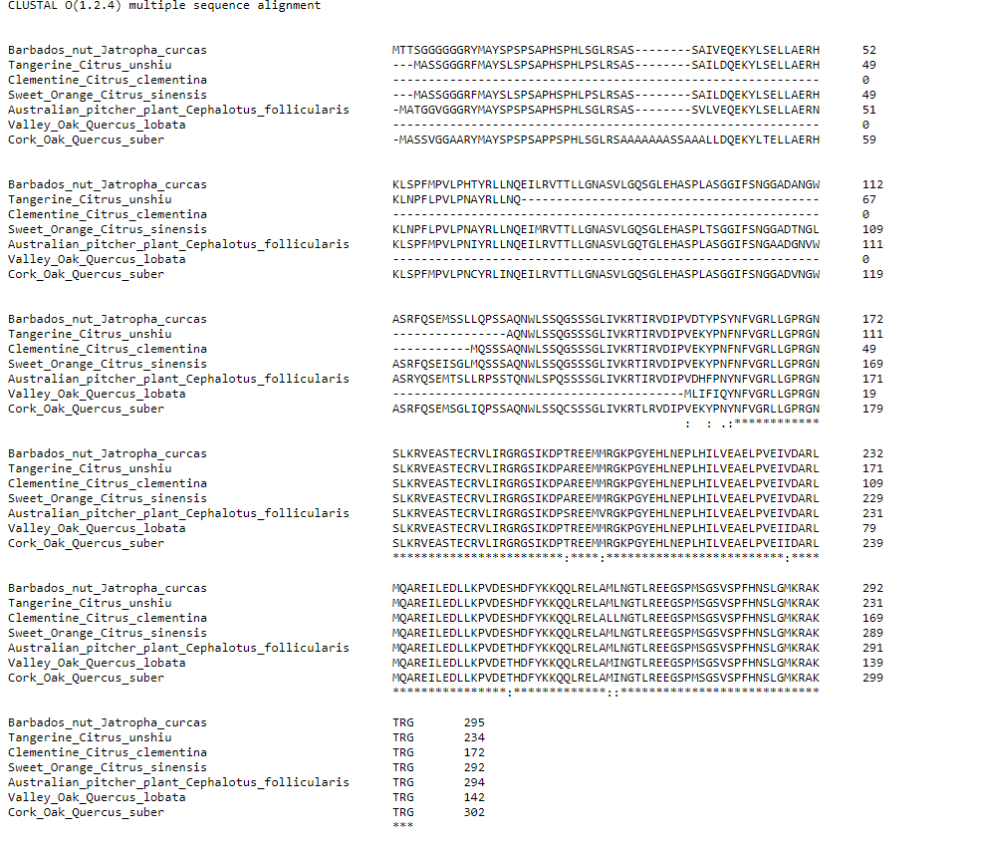

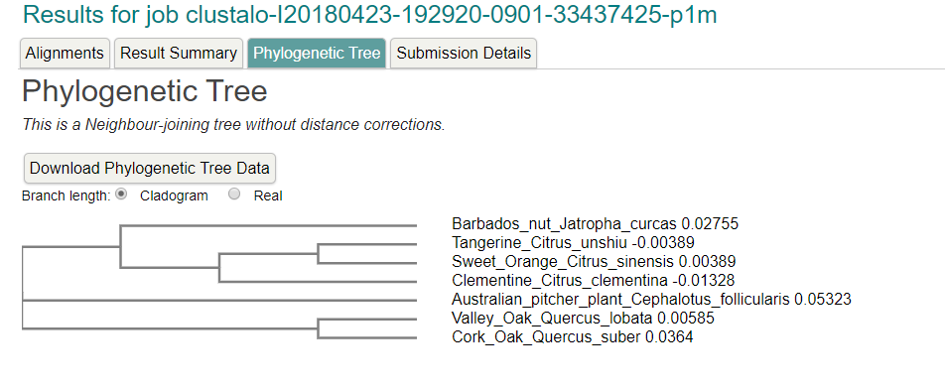

Region: chr8:730346..736630 (6.29 Kb)

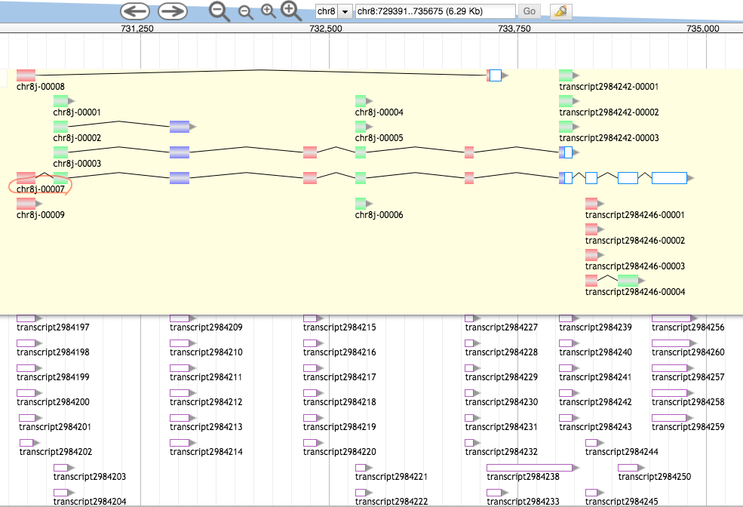

>7ed3267c-1f29-49ec-a967-0a36bab69f8b (sequence:mRNA) 199 residues [chr8:730430-734875 + strand] [peptide]

VSVSEEEVAQEKEKEKEMEGTSTTVPFKNLHSREYQGHKKKVHSVAWNCTGTKLASGSVDQTARLWHIEP

HGHGKVKDIELKGHTDSVDQLCWDPKHGDLIATASGDKTVRLWDARSGKCSMQTELSGENINITYKPDGT

HIAVGNRDDELTILDVRKFKPMHKRKFSYEVNEIAWNMTGEMFFLTTGNDILLLEVLIP

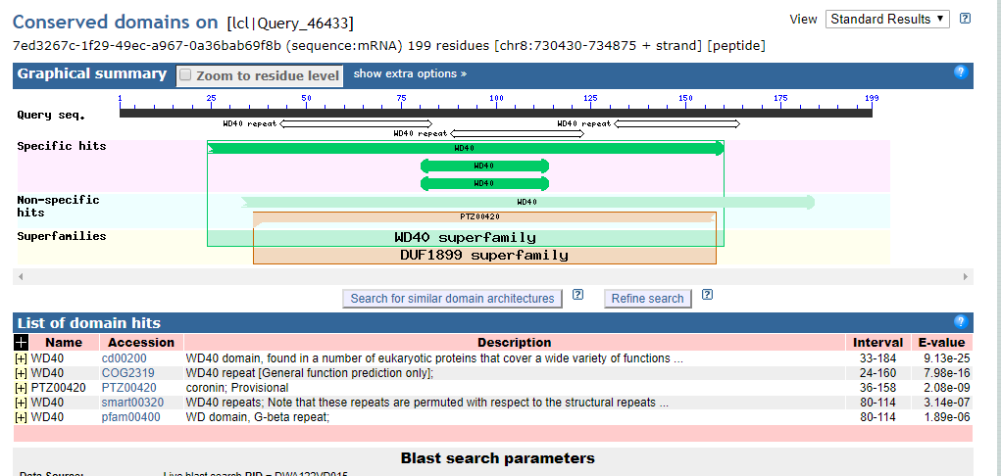

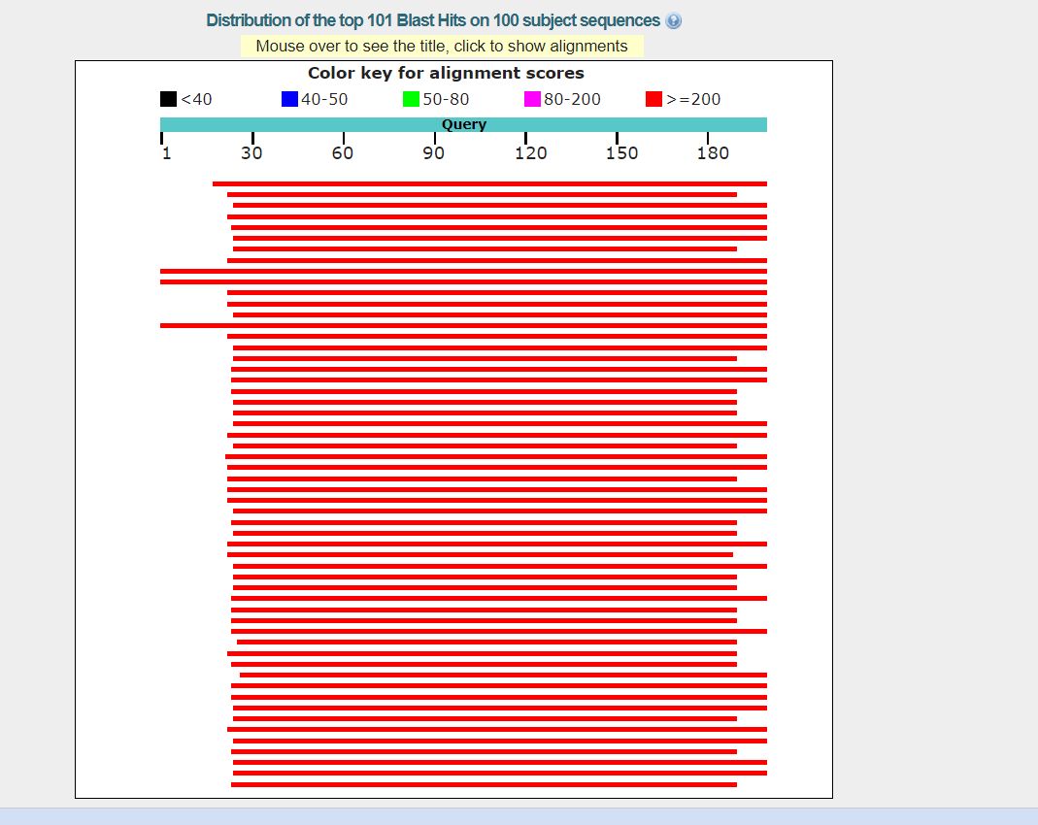

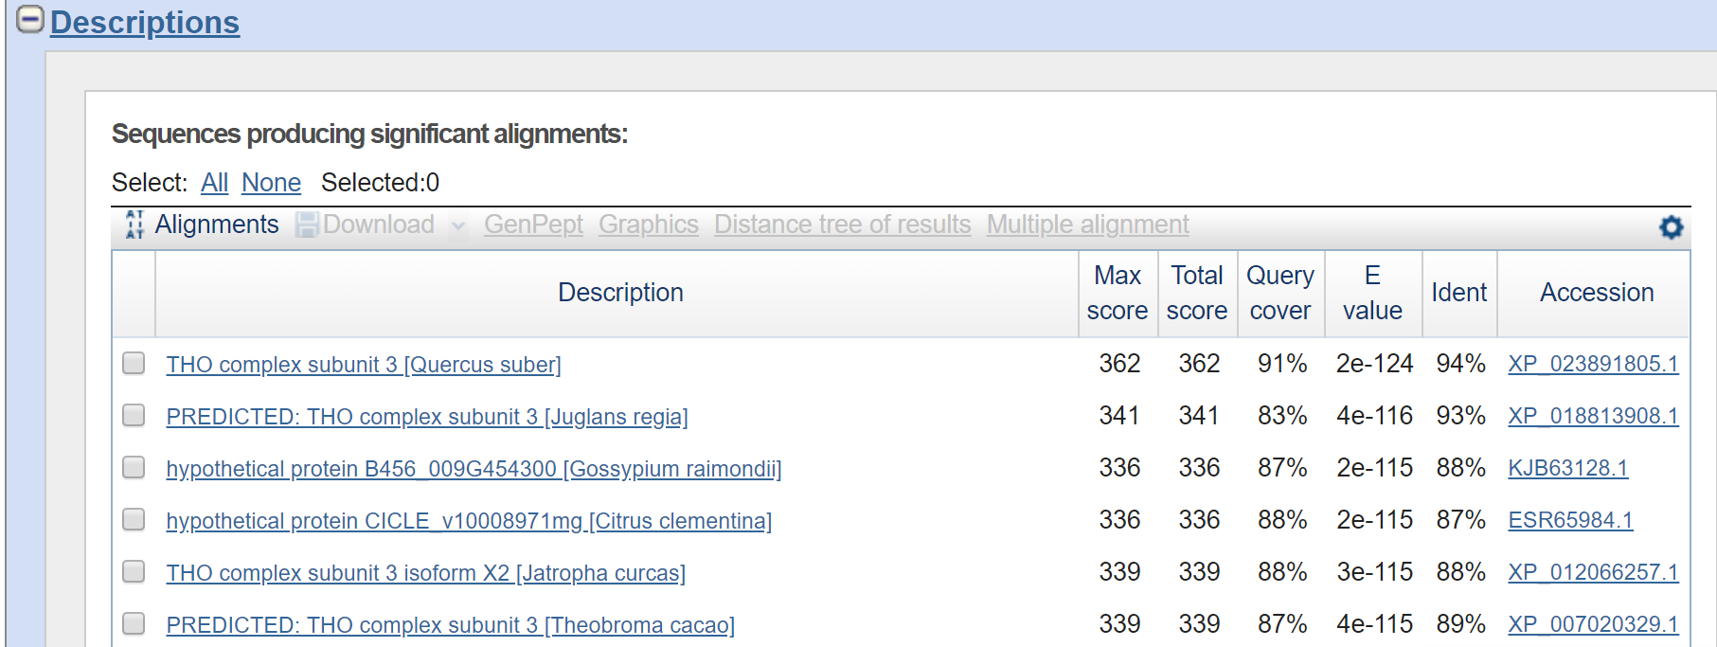

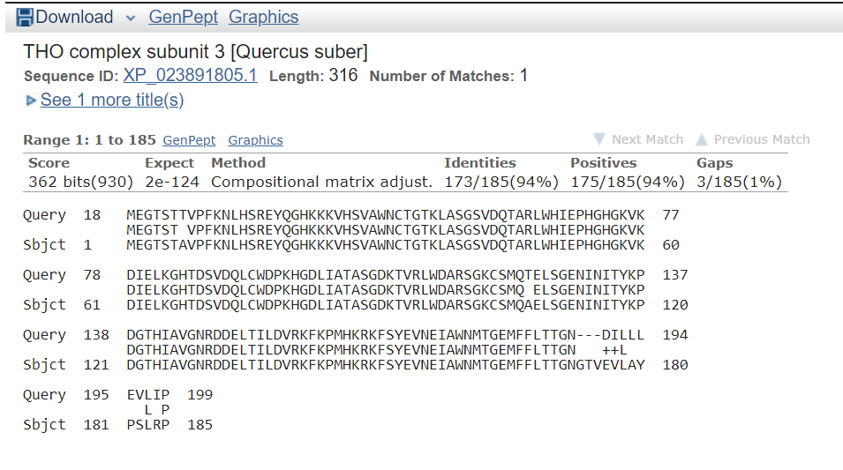

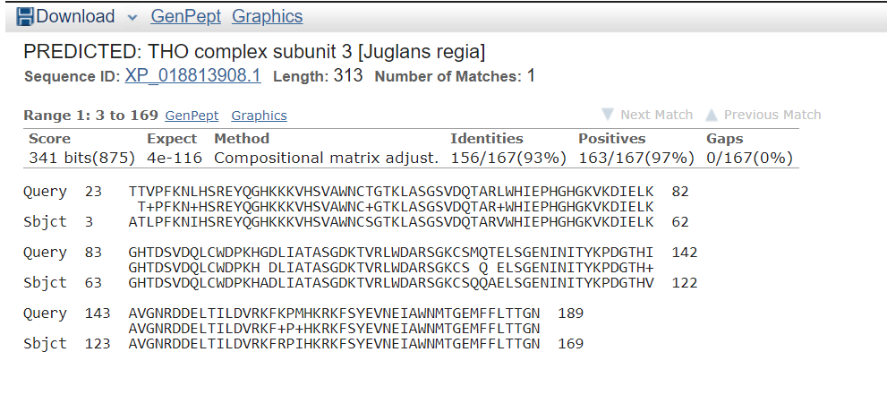

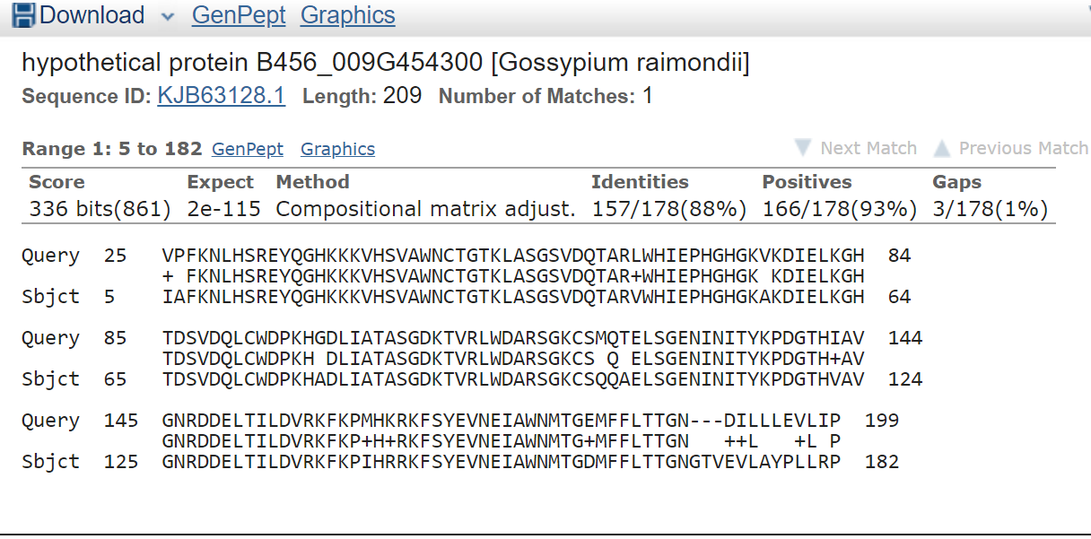

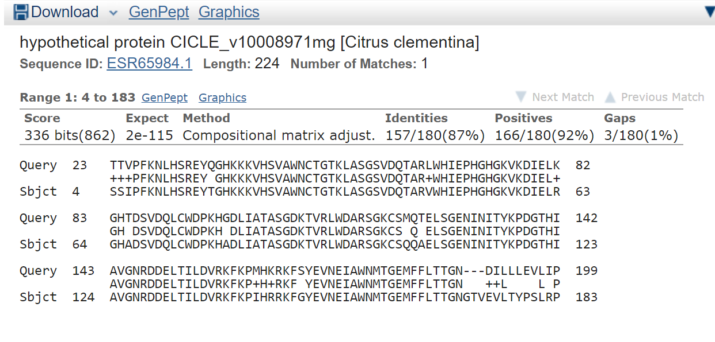

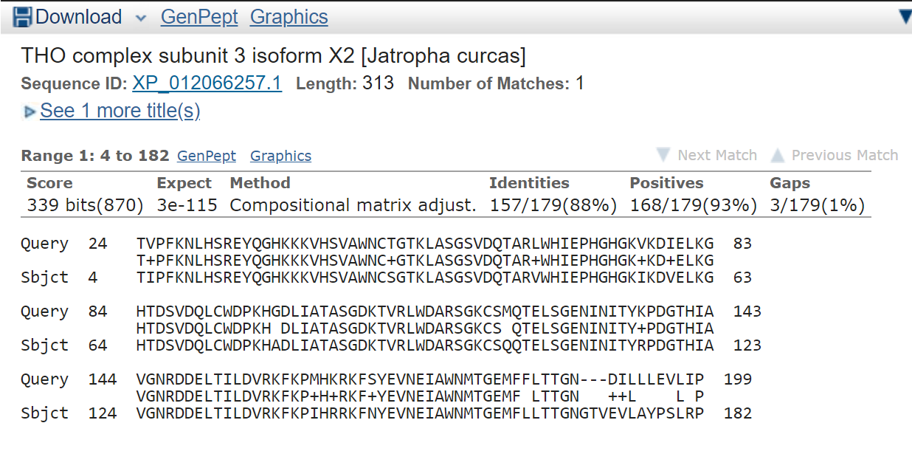

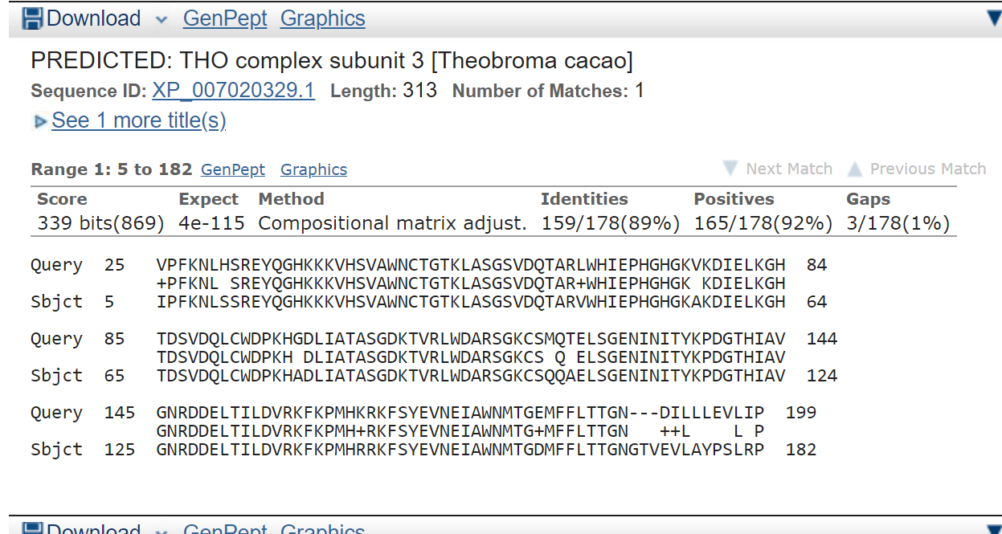

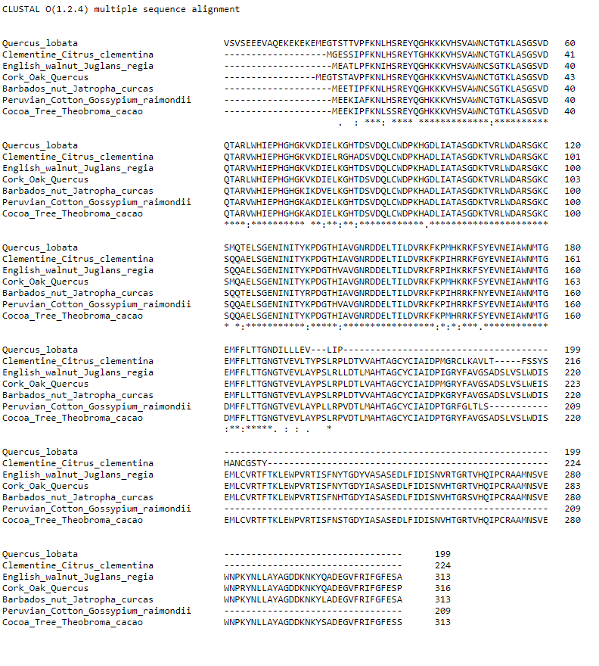

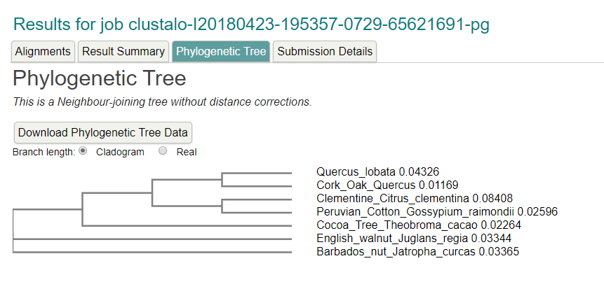

Region: chr8:750116..756400 (6.29 Kb)

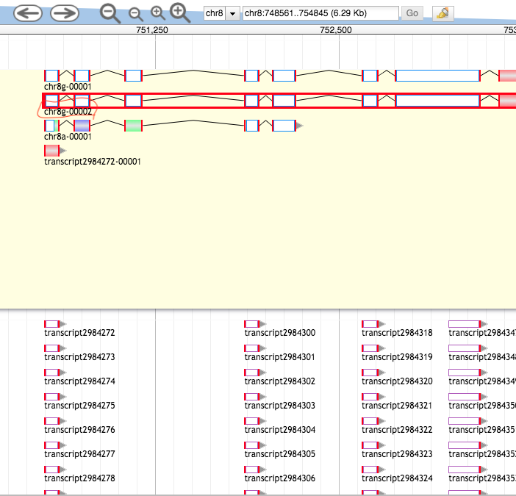

>749cc0cf-94ce-46e8-ad7b-691878547166 (sequence:mRNA) 644 residues [chr8:750495-761746 + strand] [peptide]

MTATHQLEVAVMSIAYVGRSLLLTSISSSSINSVHLDGGNVFINLLMVSLSNALLGMDANDPPKTLATMQ

LIGSIFSNLASLDDNIDGLLFMRISLSQWLDEFLSRLFSLLLYLEPSSVLNEGLNSPATSGTFLVEYSSY

YYCMLEIMLGRLSKSLYDQALRKISKFVKTNTLPGAIEEVGLLCSACIHSNREEAVIHLIEPLLLSVINS

LEDTPVMGFKEGEISKASISIKAKPTLSPALETTINYRLKVLSIAISYGGPALLRYKDQFKEAITSSFDS

PSWKVNSAGDSLLRSLLKSLTRYYPIDQYKSILSHPDAAALEDWISTKDYTNGEPVMPPKWHIPSDDEVQ

FANELLDLHLQSALDDLYRTCQARIHSGPGDRNEHLKVTLLRIDSSLQGVLSCLPDFNPSSRNGTVEDPD

HAPFLIAGATGSSVGGTELREKATEVIHAACKYLLEEKSDDSILLILVIRIMDALGNHGRCWYDAWSGEA

WNLESAAIKEPSINFIVSSNYKGKRRPRWYLIDKAYLHSMWRALKSSYNKFCARGNFYPSNHVILLIDDL

LKLSLHNYGTVRRLAGKTLLKMIERWPSMISKCVLSLTENLRDSKSSEHVVLGSCAVLASKTVFKHLAMD

PKSFCSFIRGILLR

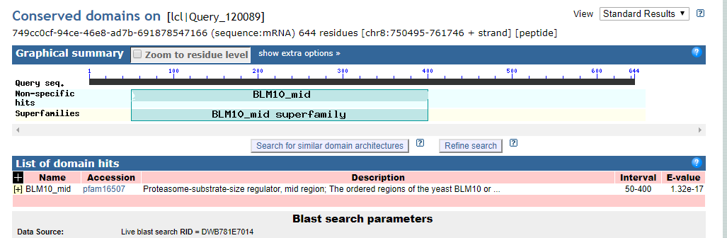

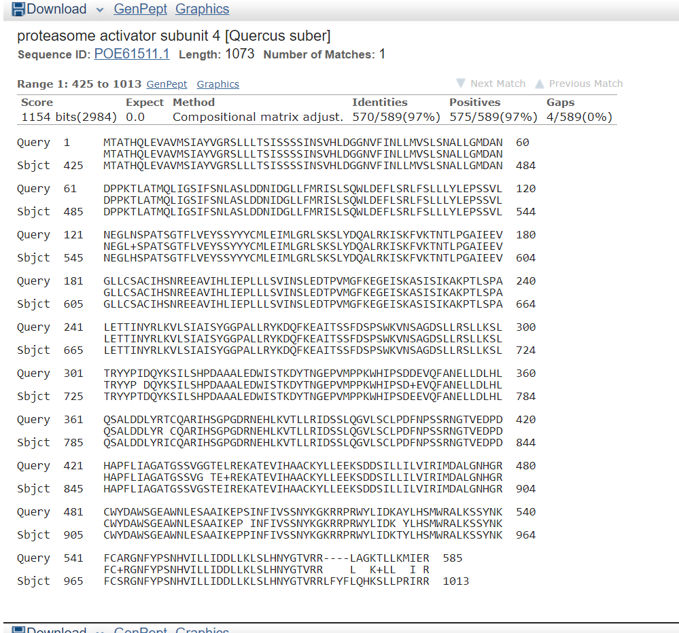

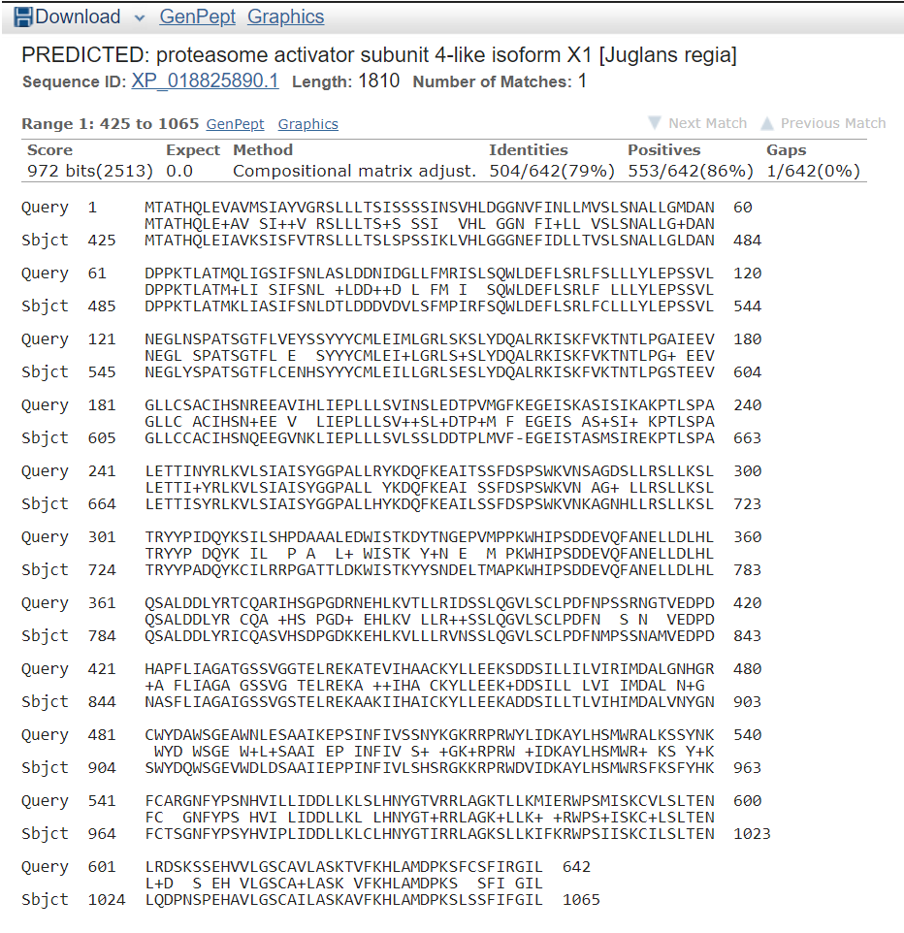

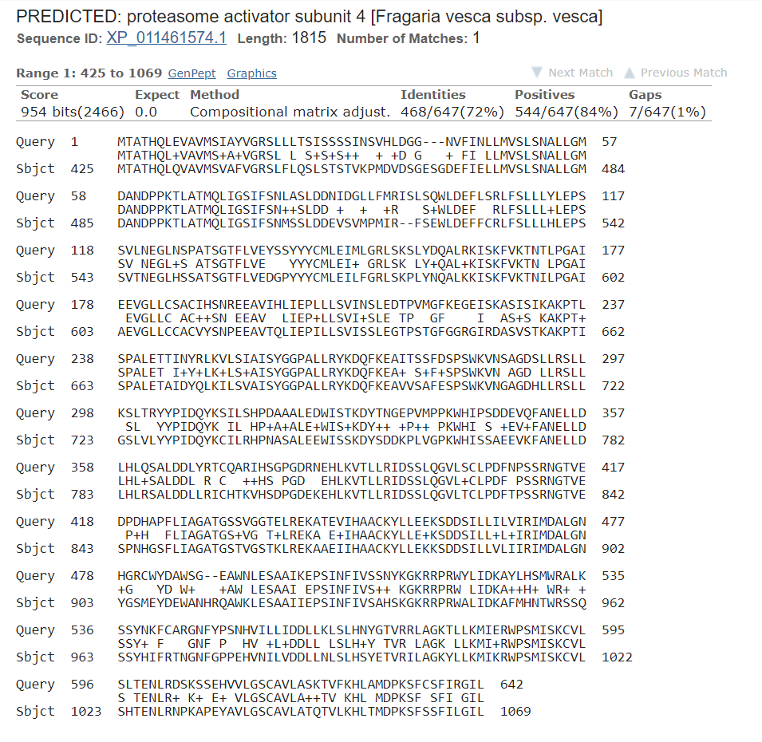

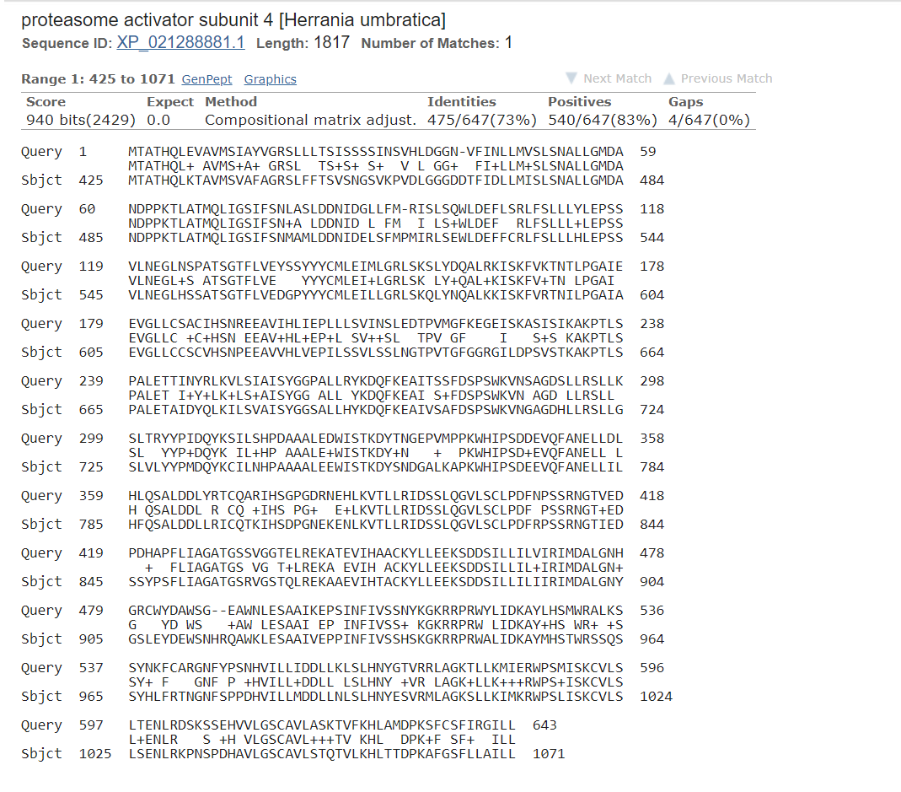

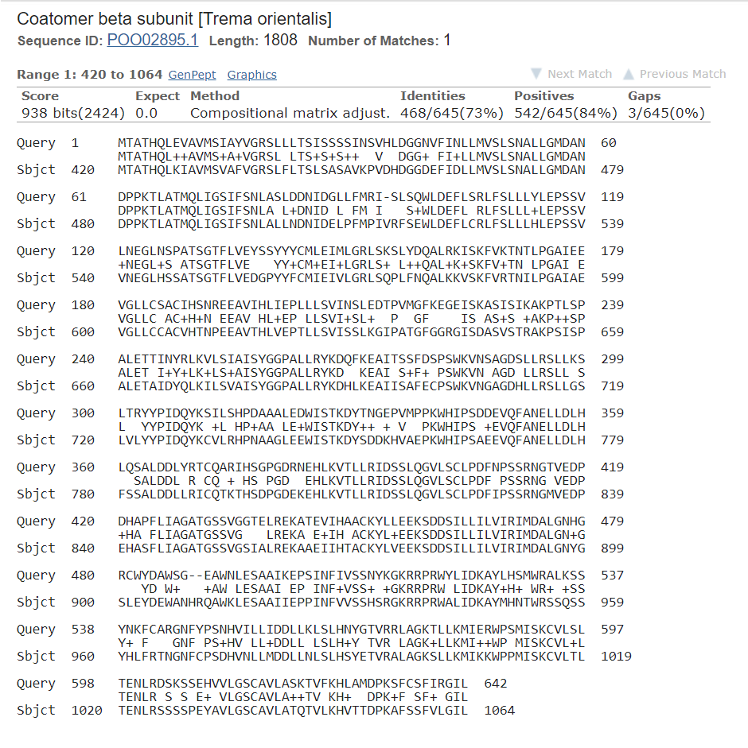

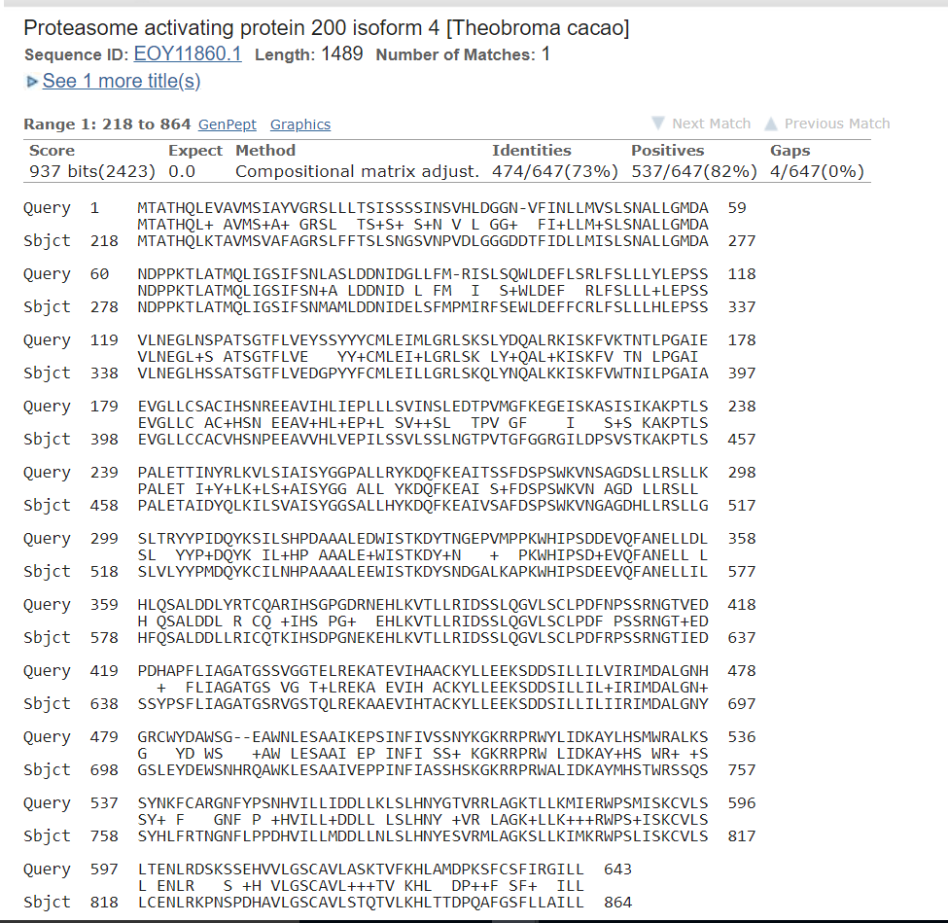

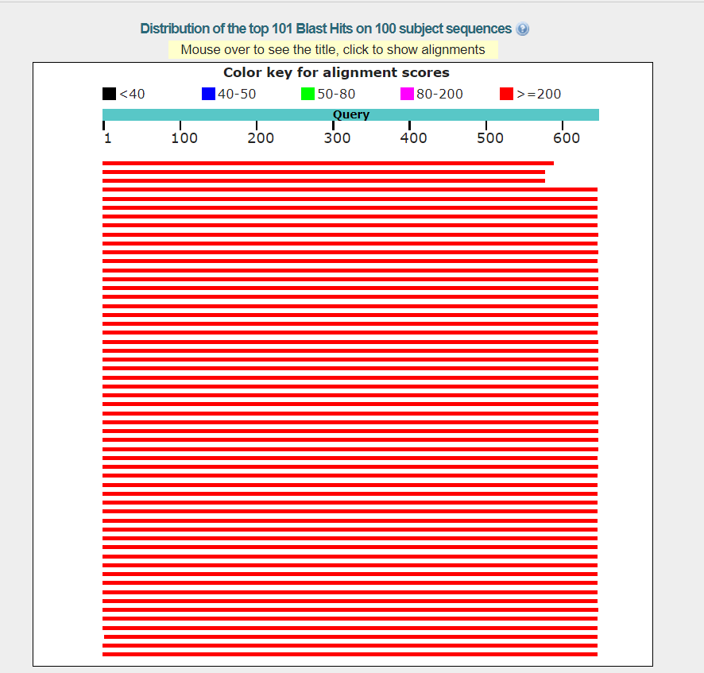

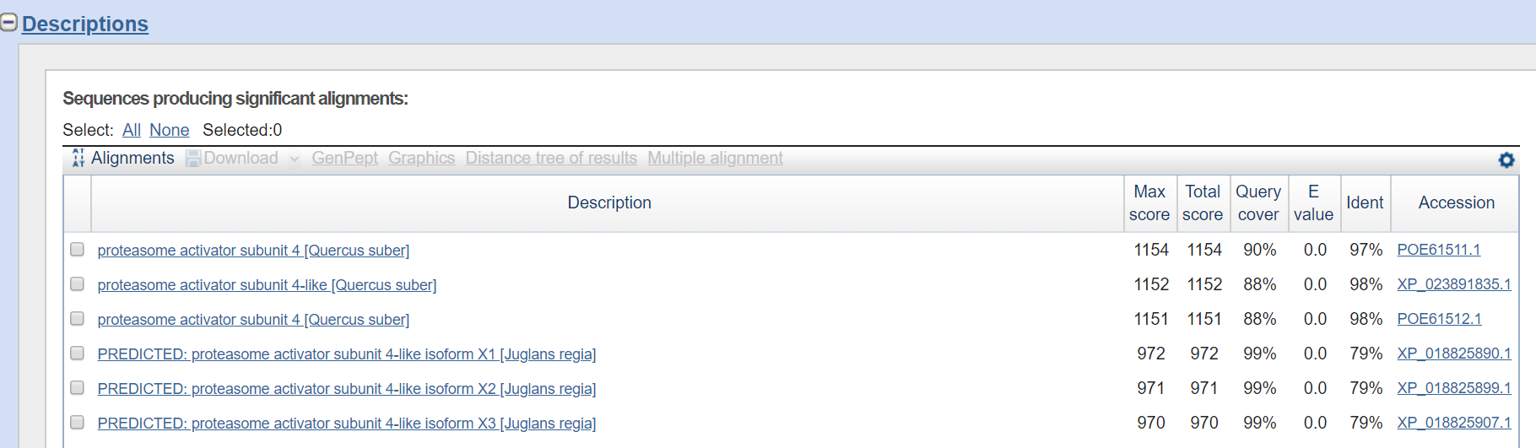

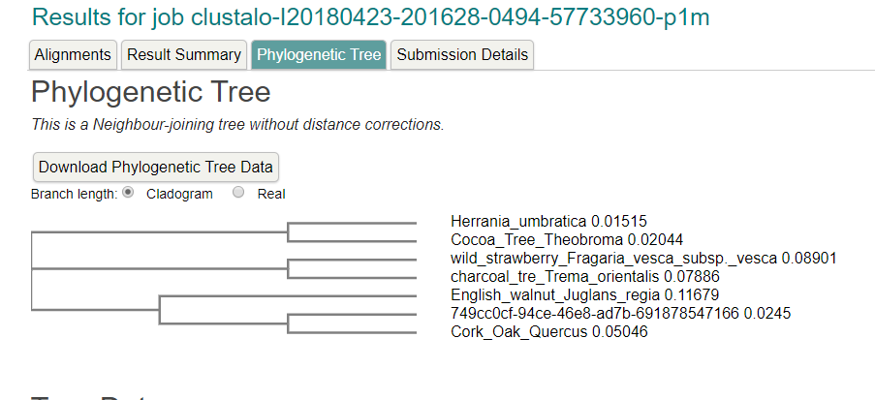

Region: chr8:762831..769115 (6.29 Kb) ERROR: NOTHING FOUND

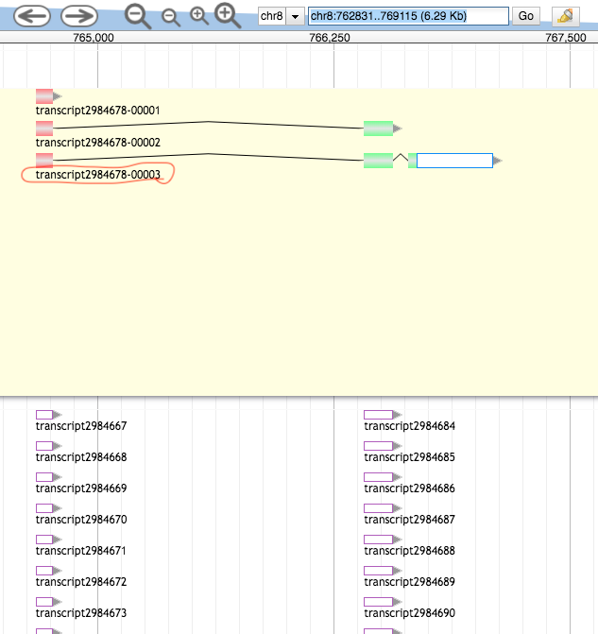

>63a06a12-9680-4118-a40e-2f932fd1fdf2 (sequence:mRNA) 95 residues [chr8:764673-767092 + strand] [peptide]

NMSGGQSVASIHGPVLALTACVLSSPYDMPSWLPEHVILLACFGGEPSPVKSTVTKAVAEFRRTHADTWD

IQKNSFTEEQLEVLADTSSSSSYFA

Region: chr8:774501..780785 (6.29 Kb)

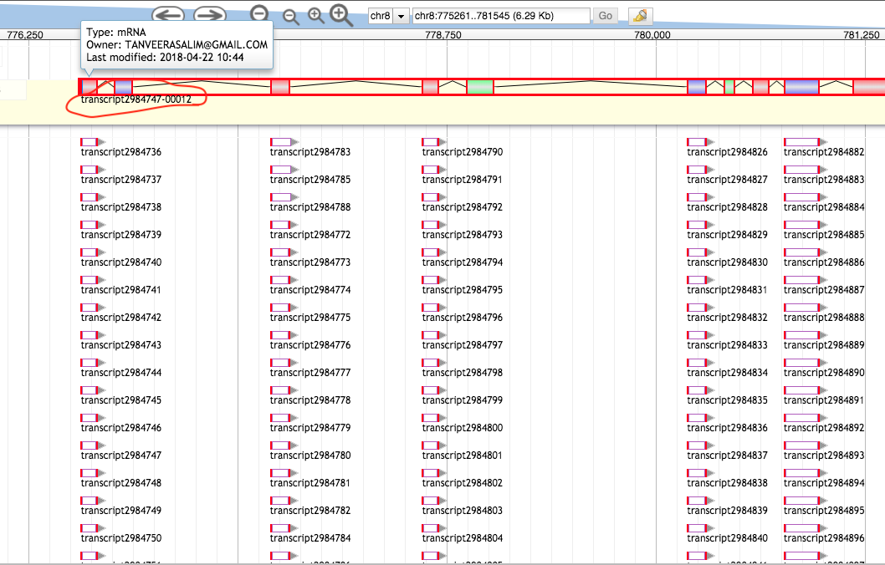

>03743ceb-c990-4b6b-af2b-1d16d080494d (sequence:mRNA) 588 residues [chr8:776562-787077 + strand] [peptide]

FIKAKSDVSLEDVSTLVEIGLELFKNSQNKLYAQVRWGNILVRVLNKYRKKLSLKVQWRPLYDTLVNTHF

TRDTGPEGWRLRQRHFEAITSLVRSCRRFFPPGSAFEIWSEFRSLLENPWHNSSFEGSGFVRLFLPTNLD

NQDFFTNDWIKSCIDLWDSMPNCQFWNSQWAALVARVVKNCNSIEWECFLPTLFARYLNMFEVPVANGSG

SYPFSVDVPRNTRFLFSNKTVTPAKAIAKAIVYLLRPGSLMQDQFEKLVNLLEQYYHPSNGGRWTYSLER

FLFHLVIQFEKRLQHEQQNTENSRQPELLLGRSERTYFVNVVLKLIERGQYSKNEHLSETVAAATSVLSY

VEPSLVLPFVASRFHMALETMTATHQLKIAVMSVAFVGRSLFLTSQSTSVESVESGDEFTDLLMVSLSNV

LLGMDANDPPKTLATMQLIGSIFSNLAYLDDNIDESSFLPMIRFSEWLDEFLCRLFSLLLHLEPSSVMNE

GLHSSATSGTFLVEDGPYYYCMLEILLGRLSKSLYTQAKPTLSPALETSIDYQLKTLSVAISYGGPALLR

YKDQFKEAIVSAFDSPSWKVHLPSPCGF

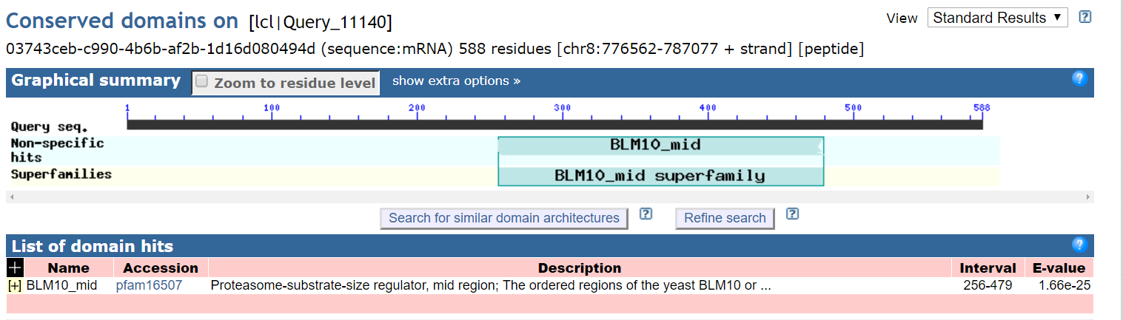

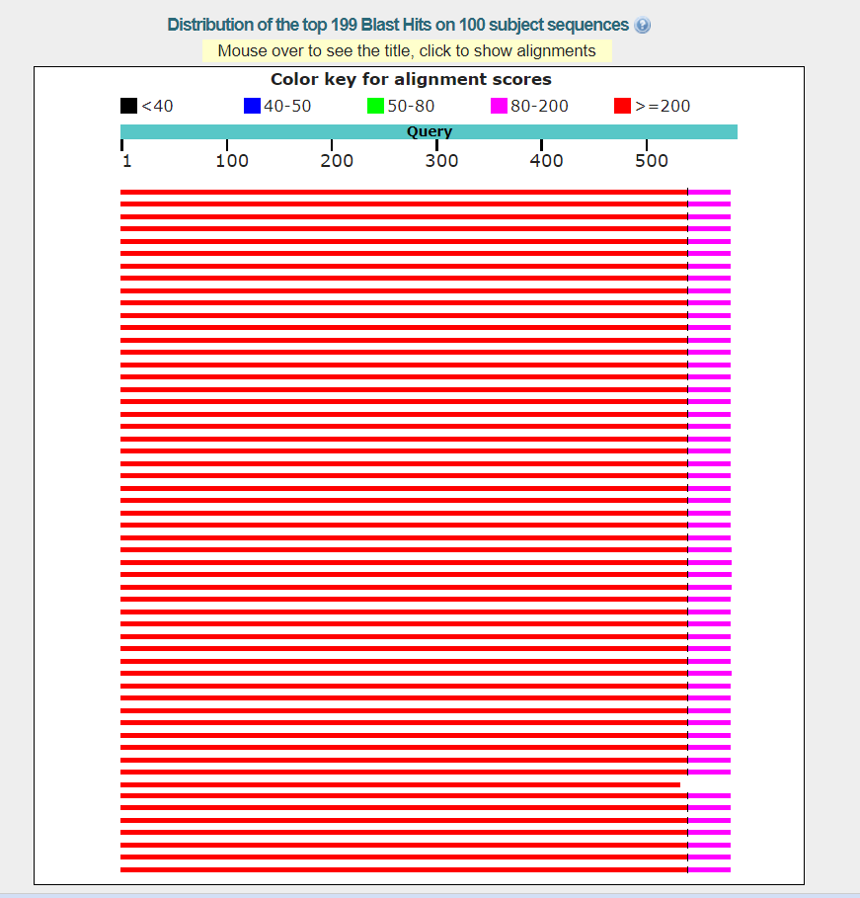

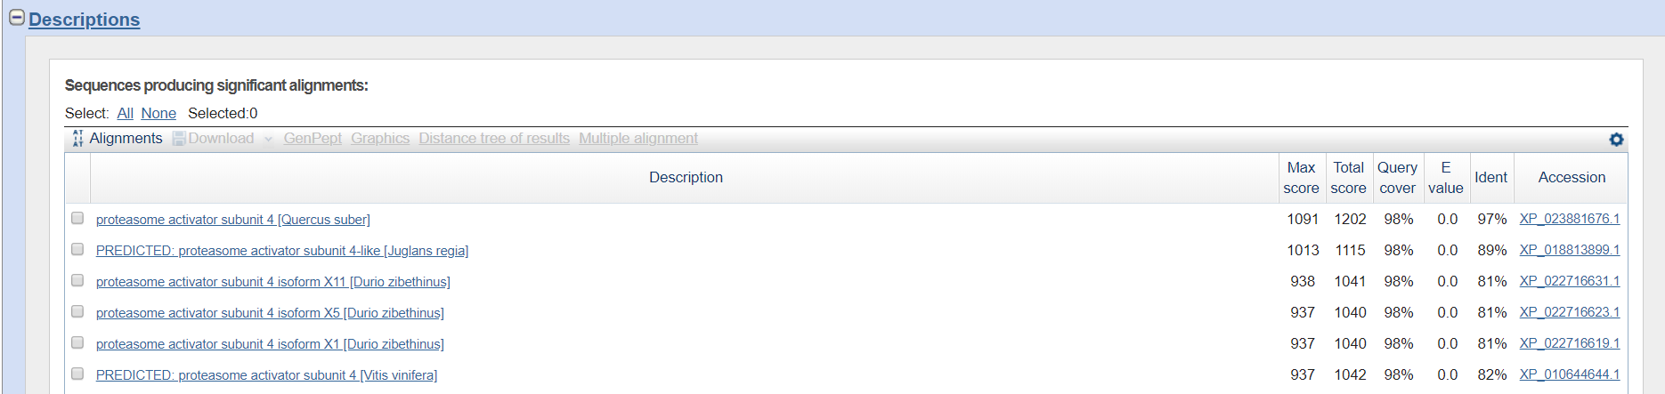

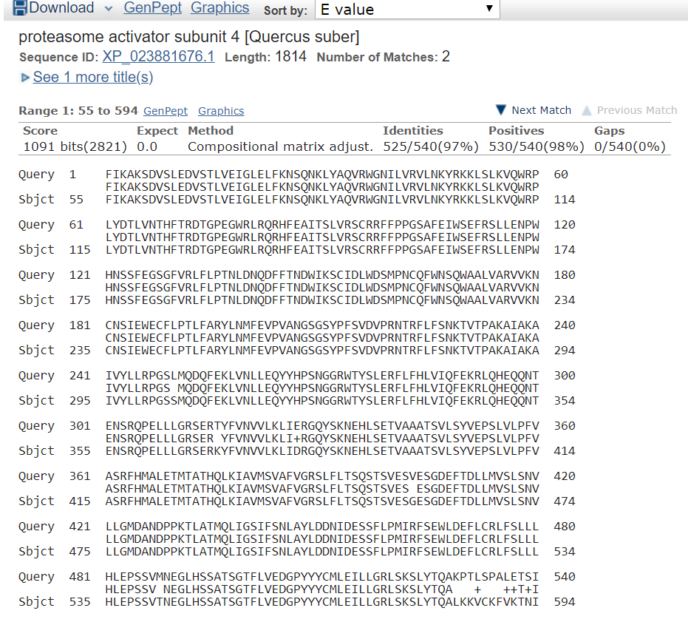

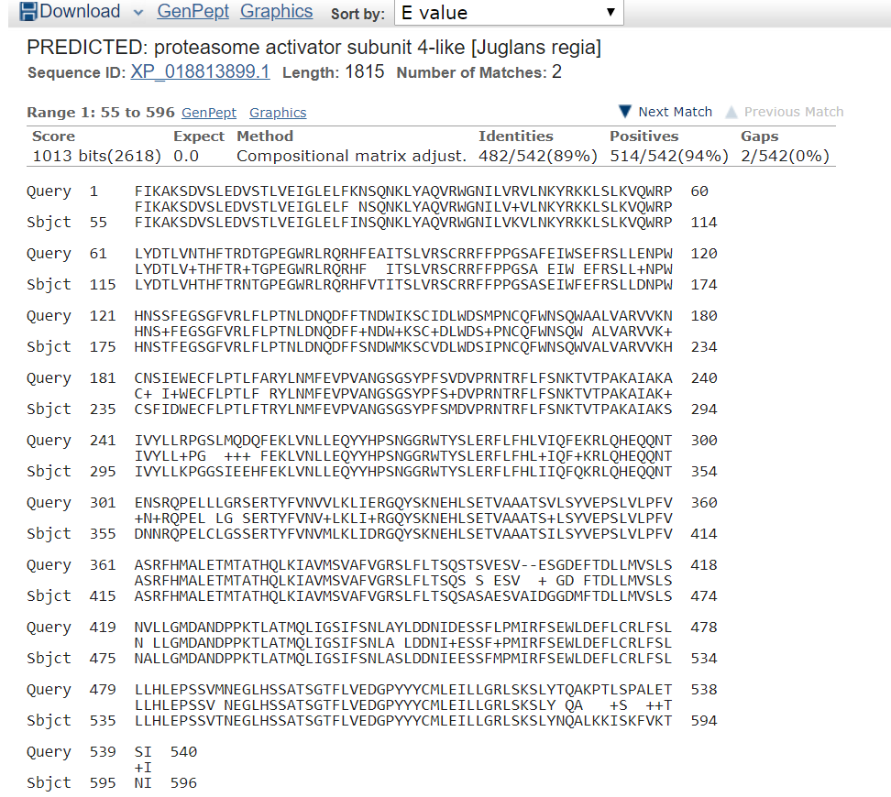

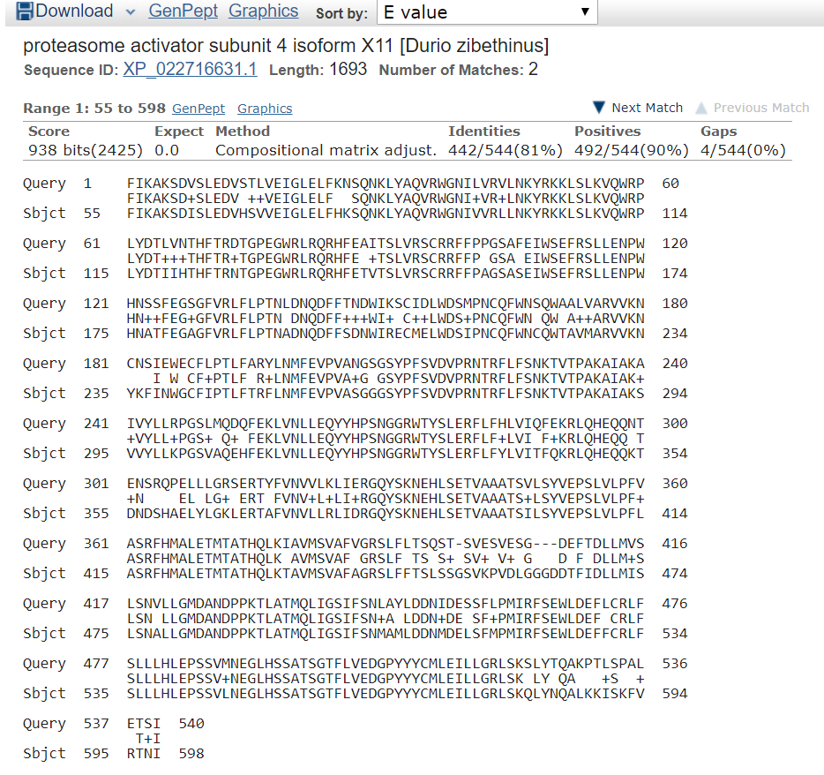

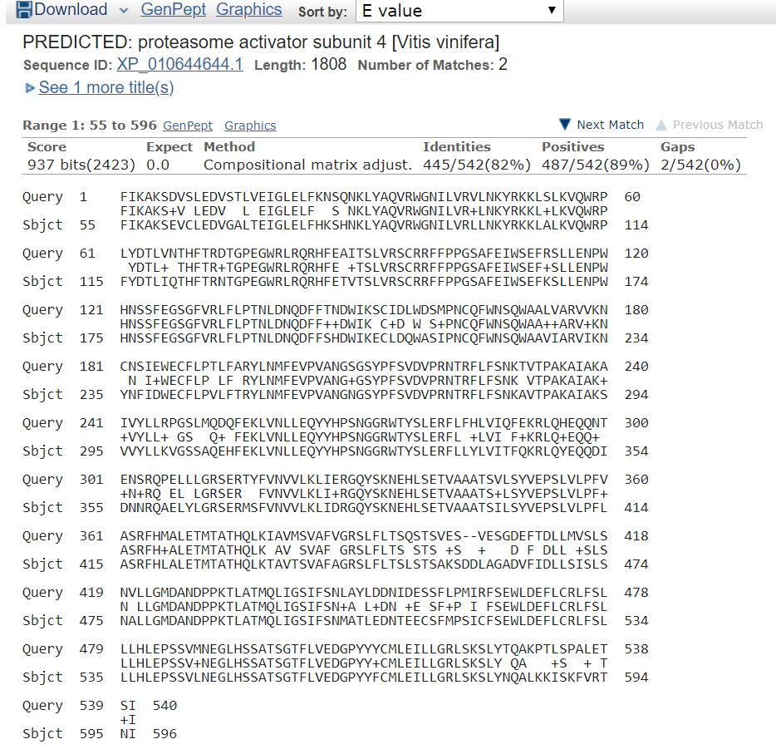

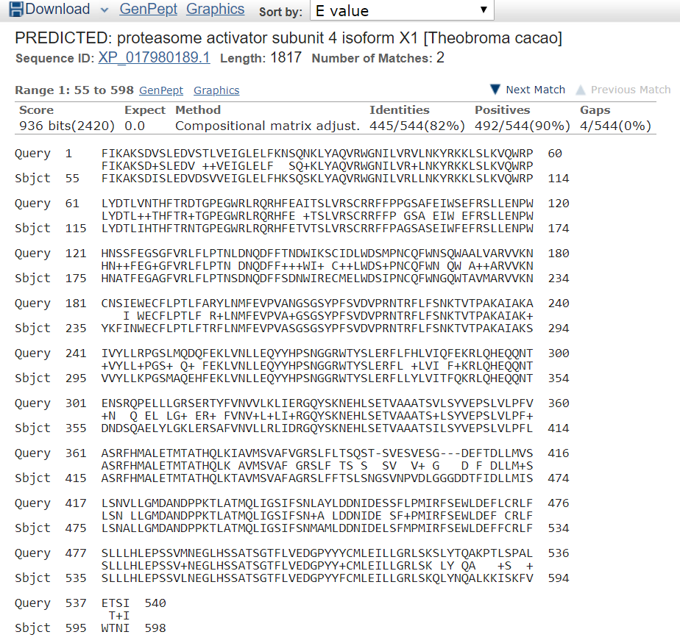

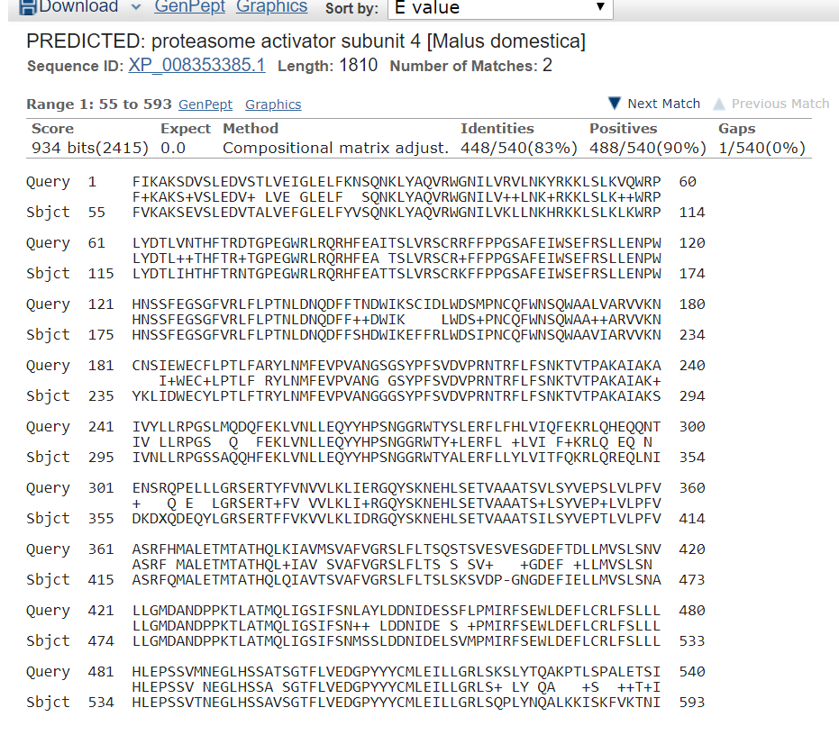

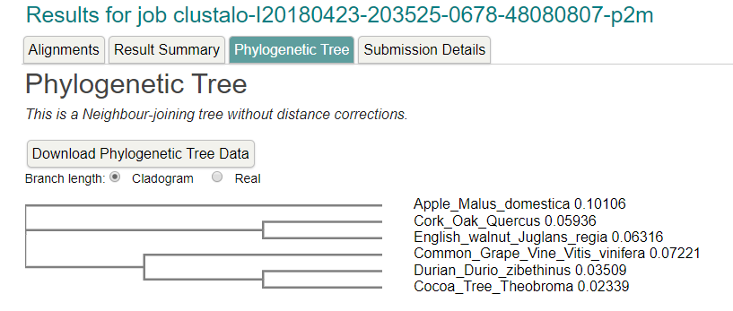

Region: chr8:795344..801574 (6.23 Kb)

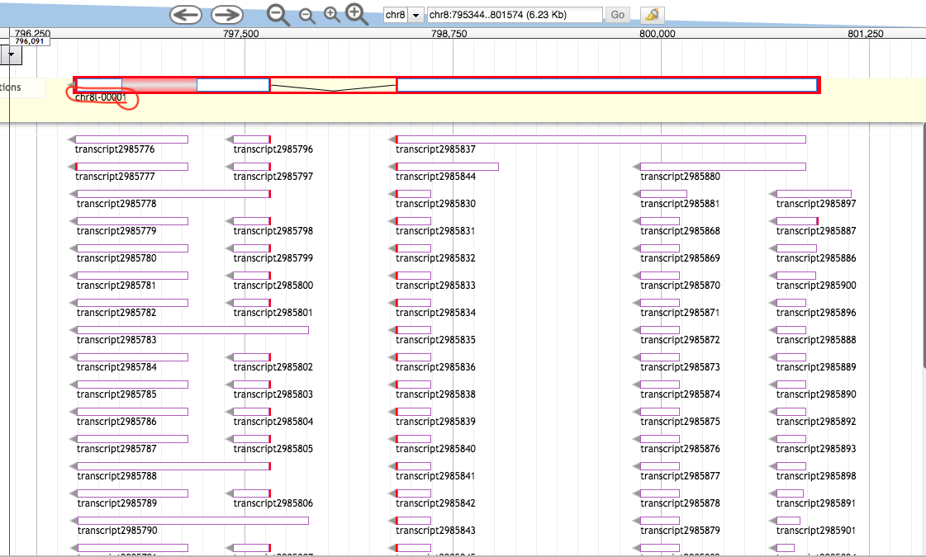

>da72fd12-6192-471d-82ef-9fd3a4cd88a5 (sequence:mRNA) 150 residues [chr8:796485-800948 - strand] [peptide]

MLVYIYLLCFYMCLCWQVYSQPLFANVERWFADKFPSSGFVNDNYTLKLPLLPEIRLNLLRLCFRSIYVV

STTAIAMLFPYFNQVLGVLGGLNFWPLSIYFPVEMYFKQMNIEAWTTKWILLRTFSMFCLLVTLFSLIGS

IEGLITAKLS

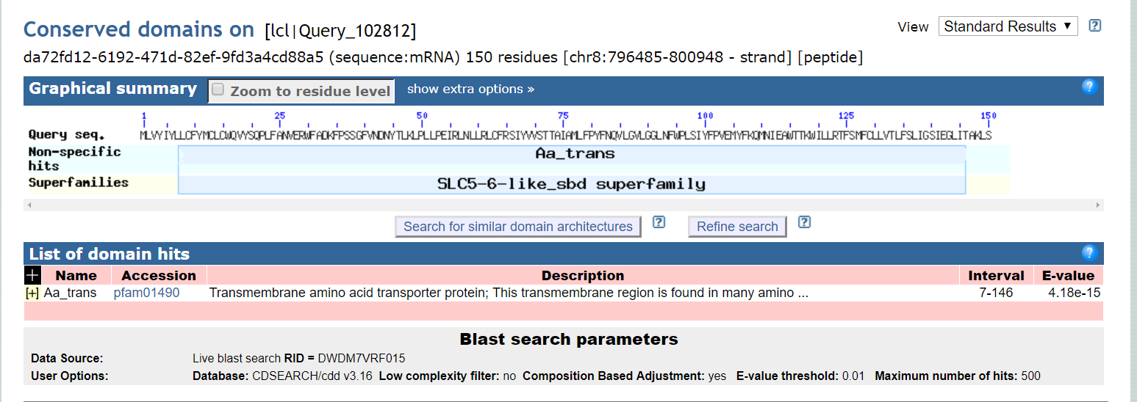

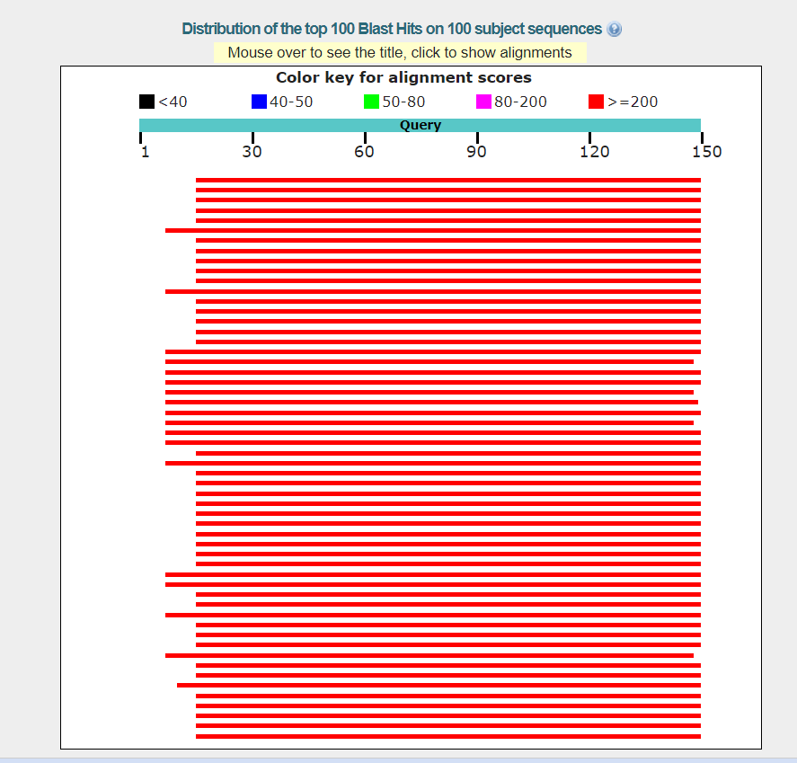

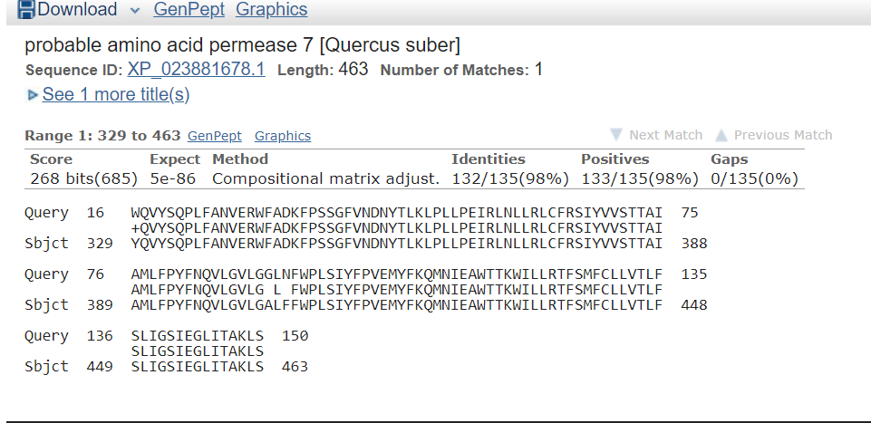

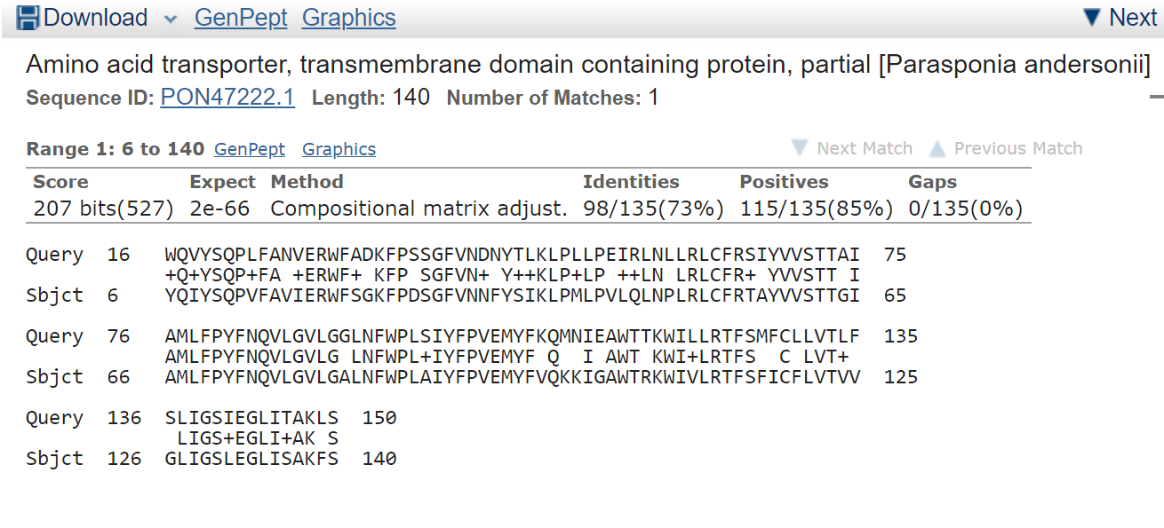

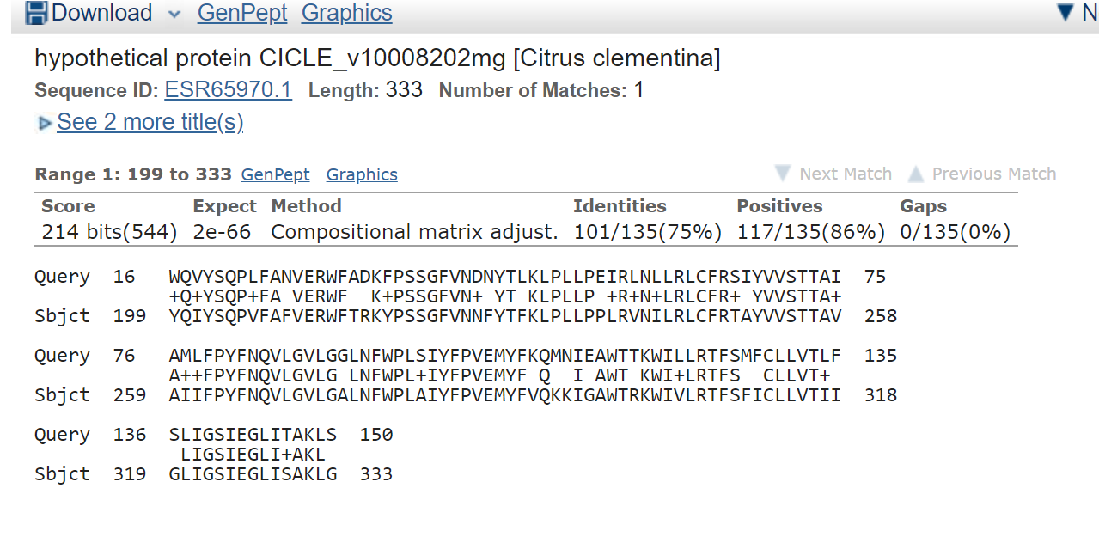

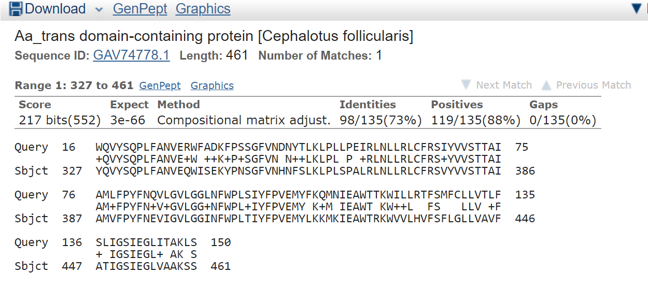

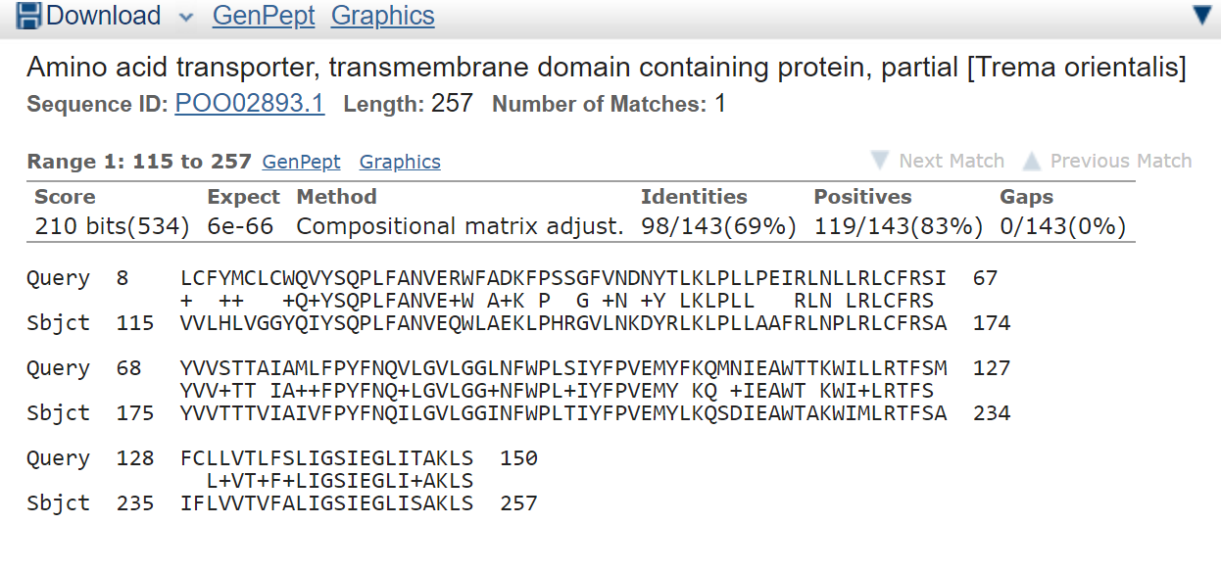

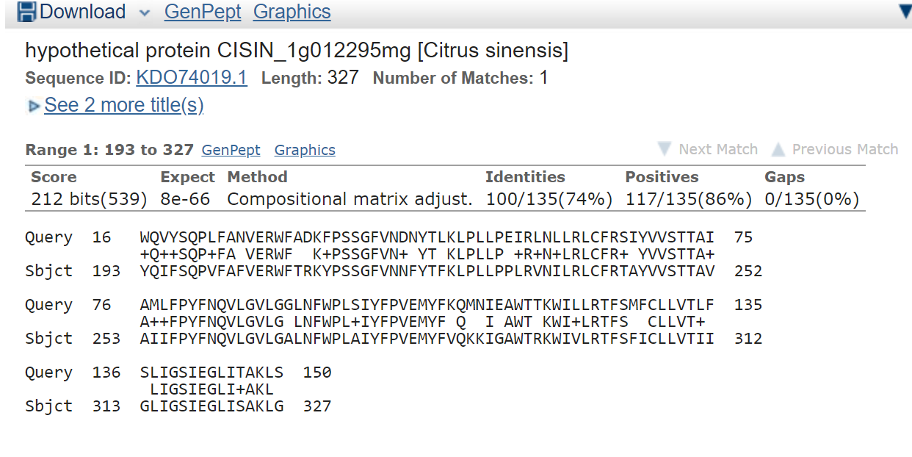

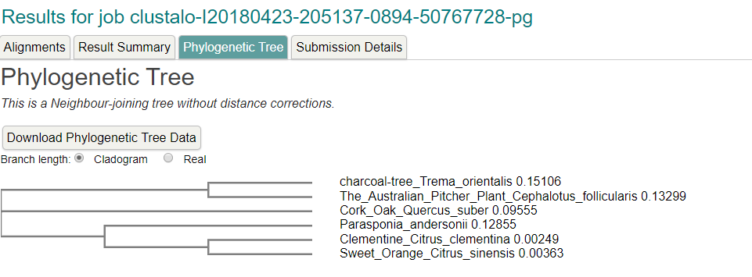

**Sorry,** the above were done

Incorrectly you have to REDO Everything All OVER AGAIN For the Regions

Below the Previous Sorry for Genomic Region 701,000..795,000. And the genomic region 772,500..793,750 NEEDS TO BE CHECKED WITH MULTIPLE SEQUENCE ALIGNMENT. If the other

Regions go out of bounds…then you should probably delete the others too.

Chr8 742500

>17678ab3-55da-4b01-8c73-7e8d1b11e8c5 (sequence:mRNA) 1693 residues [chr8:742485-762148 + strand] [peptide]

MHLYNAWLPPHVAEETKKEKESFARVVRTVNELYRPDDPDSVYA

TLTWIPVIKLFIHAESEVALEDVDTLVKIGLELFHVSQNNLHAQVKWGNILVKLFNKYHK

KLSLKVQWRPFYDTLISTHFTRNPGPEGLRLKLRHFETITSLVQSCRRFFPPGSAFDIWS

EFRSLVENPWNNSSFEGSGFVRLFLPTNLDNQDFFSCEWIKECLNLWDSIPNCQFWNCQW

AGVIARTVKNCNFIDWECFLPTLFSRFLNMFEVPVANGRGSYPFPLCVPKNTSFLFSNKT

VTRMKAIAKSIVYLLKPHGSAQEQLETFINLLEQYYHPSNGGQWTYSLERFLLHLVTQFK

KRLKHEQQNPNNSRCAELYLGRSERTKFVNVVLKLIDRGQYSKDKDLSETVAVATSILSF

VEPSLVLPFVASRYYIALETMTATHQLEVAVMSIAYVGRSLLLTSISSSSINSVHLDGGN

VFINLLMVSLSNALLGMDANDPPKTLATMQLIGSIFSNLASLDDNIDGLLFMRISLSQWL

DEFLSRLFSLLLYLEPSSVLNEGLNSPATSGTFLVEYSSYYYCMLEIMLGRLSKSLYDQA

LRKISKFVKTNTLPGAIEEVGLLCSACIHSNREEAVIHLIEPLLLSVINSLEDTPVMGFK

EGEISKASISIKAKPTLSPALETTINYRLKVLSIAISYGGPALLRYKDQFKEAITSSFDS

PSWKVNSAGDSLLRSLLKSLTRYYPIDQYKSILSHPDAAALEDWISTKDYTNGEPVMPPK

WHIPSDDEVQFANELLDLHLQSALDDLYRTCQARIHSGPGDRNEHLKVTLLRIDSSLQGV

LSCLPDFNPSSRNGTVEDPDHAPFLIAGATGSSVGGTELREKATEVIHAACKYLLEEKSD

DSILLILVIRIMDALGNHGRCWYDAWSGEAWNLESAAIKEPSINFIVSSNYKGKRRPRWY

LIDKAYLHSMWRALKSSYNKFCARGNFYPSNHVILLIDDLLKLSLHNYGTVRRLAGKTLL

KMIERWPSMISKCVLSLTENLRDSKSSEHVVLGSCAVLASKTVFKHLAMDPKSFCSFIRG

ILLSSHHESLEAQKAINELFVTYNIHFSGISRSIFRTSDYHIDGTDFSNLVSQIVSLGSD

SSSLHWRYNLMANRVLLLLAMTSRNYLNSSSAILSDTAGHFLKSLKCQLPQTRILAISAL

NTLLKESPYKFSAEEQPLFSDDLWGNTKSSLEGALTRIFQEDGFFNETLNSLSLVHIITD

TESTSSGGNNGNSIFQSLTDKSITRFYFDFSASWPRTPSWISLIDSNSFYSKFARIFKRL

VQECGMSVLLALRSTLEEFANAQERSKQCVAAEAFAGILHSDVNGILGAWDSWMMVQLQN

IILAQSVESIPEWASCIRYAVSGKGRYGTRVPLLRQKILDCLATPLPPKVTTTIVAKRYA

FLSASLIEISPQKMAAGELQLHNKLLEELLGNMCHSSAQVRETIGVTLSVLCSNIRLYAL

SDNHRSHEGGNNDVNNQLMESWIELLTKRASQVLMNIQNASHSVTLETSRDVSAPDVQLN

GHSQDDVKWMETLFHFIISSLKSGRSSCLLDVIVGLLYPVISLQETLNKELSALAKSAFE

LLLWRIFWEPHLQEAVSVILSSANDSNWRTRSATLTYLQTFMHRHTFILSRTEKQKIWRT

VEKLLKDIQVEASKRACCSSSSRLNEGWG

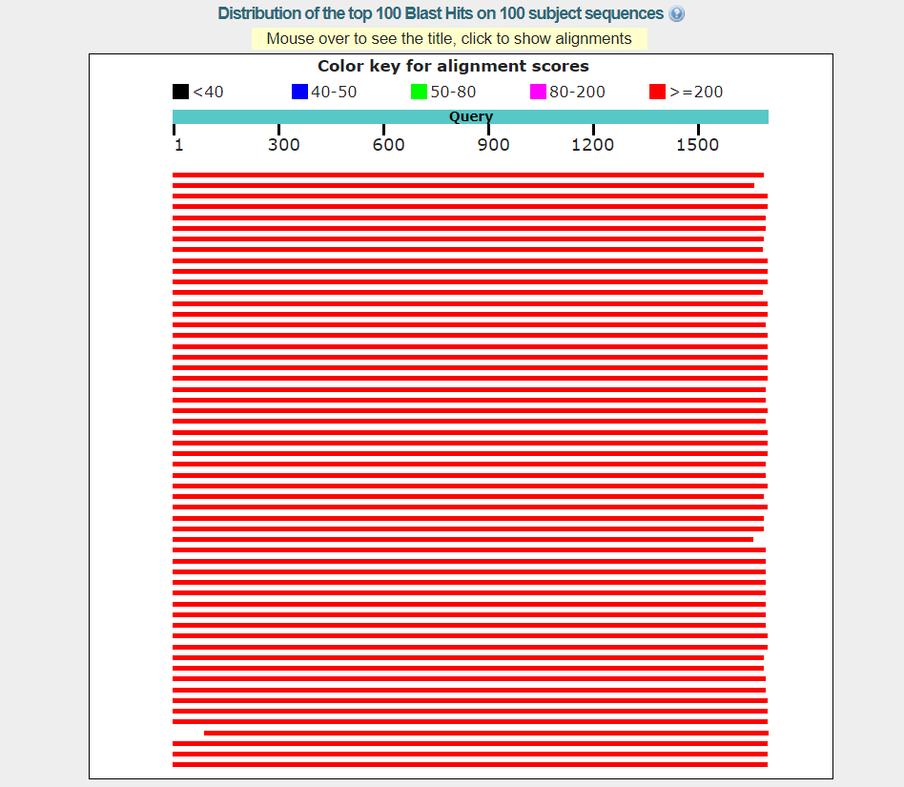

­­­­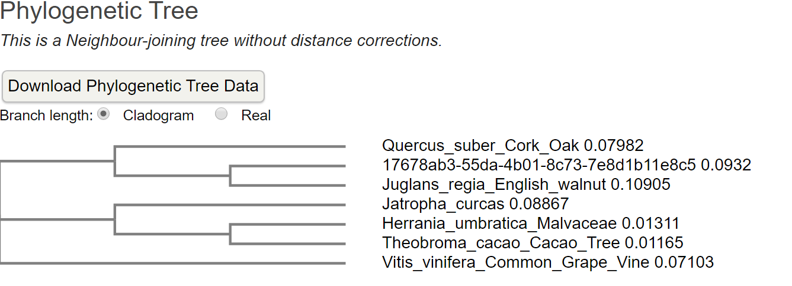

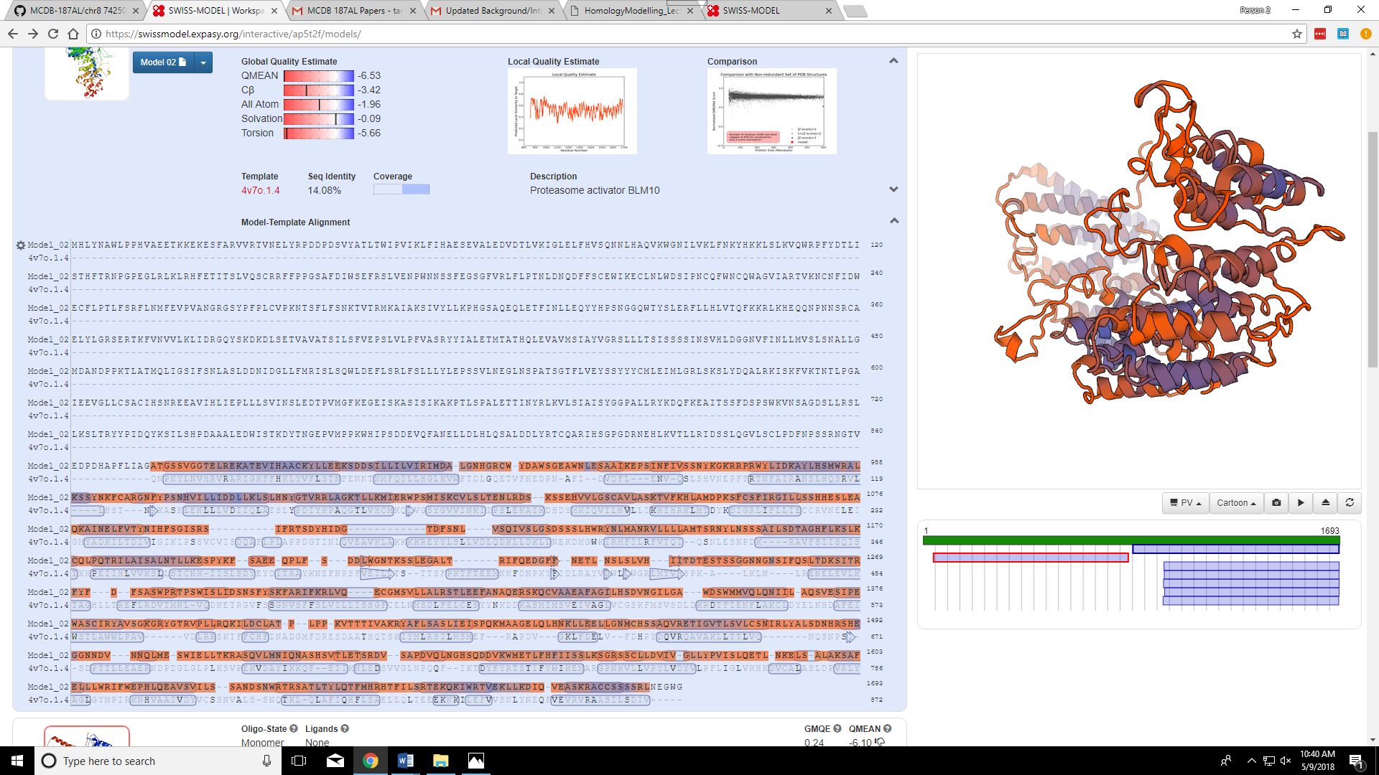

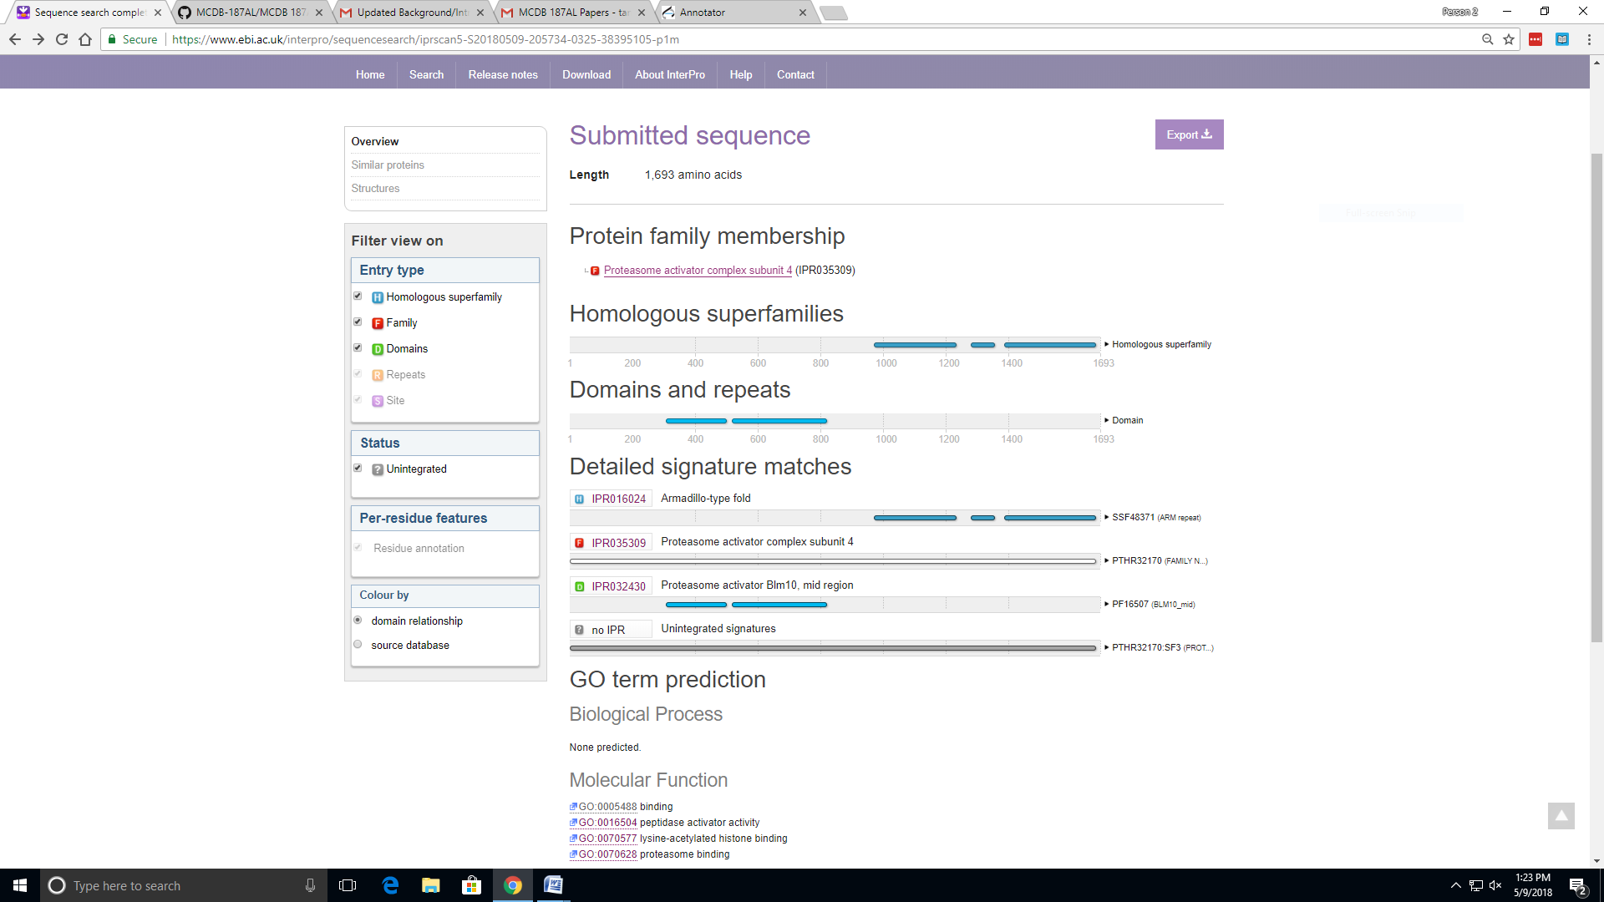

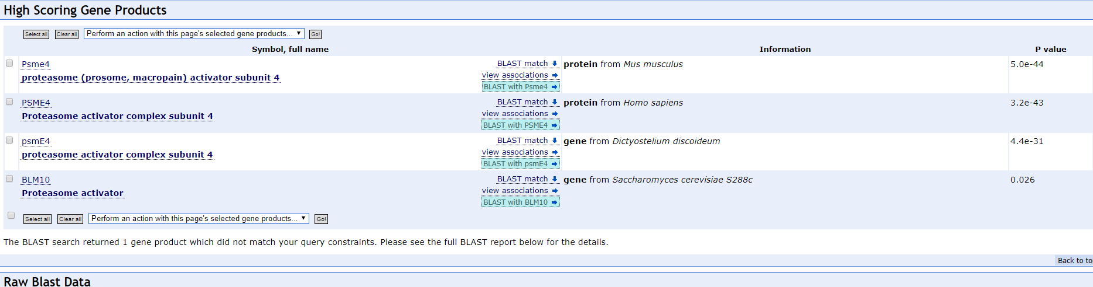

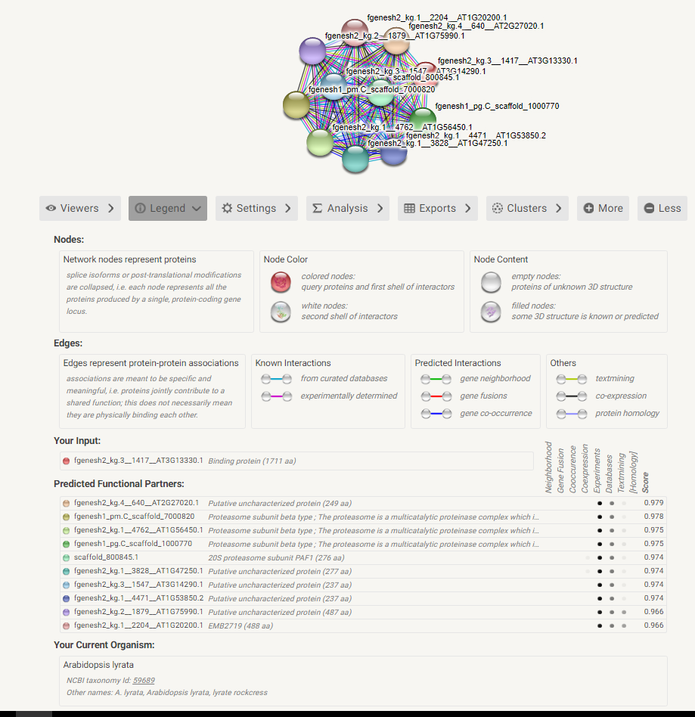

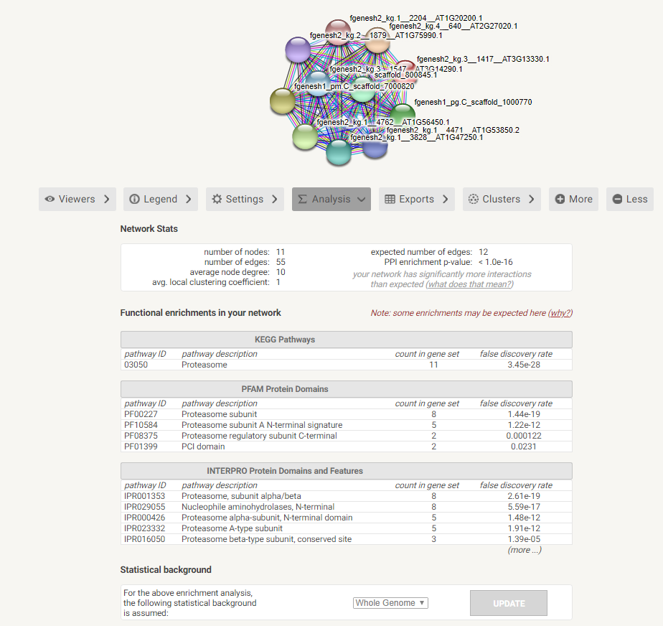

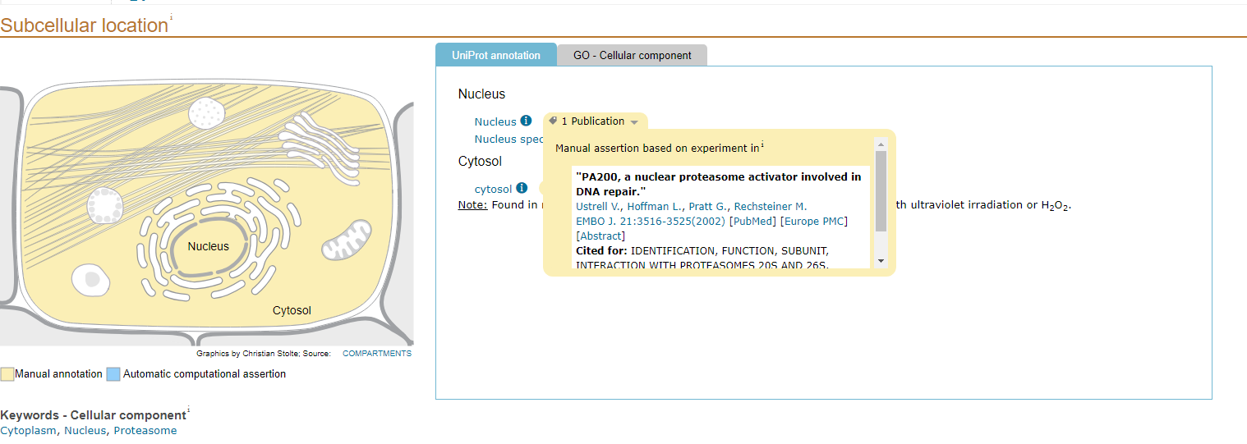

Chr8 772500­­­: Ignore This

>85c1f0ba-f6eb-45ae-93ca-01c95489d7bf (sequence:mRNA) 1814 residues [chr8:772156-793858 + strand] [peptide]

MHLYNAWLPPPVAQETKREKESFSRVVCSVKNSFKPDDPDSVYSTLKWISVIDLFIKAKSDVSLEDVSTL

VEIGLELFKNSQNKLYAQVRWGNILVRVLNKYRKKLSLKVQWRPLYDTLVNTHFTRDTGPEGWRLRQRHF

EAITSLVRSCRRFFPPGSAFEIWSEFRSLLENPWHNSSFEGSGFVRLFLPTNLDNQDFFTNDWIKSCIDL

WDSMPNCQFWNSQWAALVARVVKNCNSIEWECFLPTLFARYLNMFEVPVANGSGSYPFSVDVPRNTRFLF

SNKTVTPAKAIAKAIVYLLRPGSLMQDQFEKLVNLLEQYYHPSNGGRWTYSLERFLFHLVIQFEKRLQHE

QQNTENSRQPELLLGRSERTYFVNVVLKLIERGQYSKNEHLSETVAAATSVLSYVEPSLVLPFVASRFHM

ALETMTATHQLKIAVMSVAFVGRSLFLTSQSTSVESVESGDEFTDLLMVSLSNVLLGMDANDPPKTLATM

QLIGSIFSNLAYLDDNIDESSFLPMIRFSEWLDEFLCRLFSLLLHLEPSSVMNEGLHSSATSGTFLVEDG

PYYYCMLEILLGRLSKSLYTQALKKVCKFVKTNILPGAIAEVGLLCCACVHSNPEEAVTHLIEPILSSVI

SSLEGVPVTGFGGRGTSKSSVSIKAKPTLSPALETSIDYQLKTLSVAISYGGPALLRYKDQFKEAIVSAF

DSPSWKVNGAGDHLLRSLLGSLILYYPIDQYKCIFRHPVASELEEWISTKDYSNNELPIGPKWHIPSDEE

VNFANELLDLHFKVALDDLFTMCQTKIHSDSGDEKEHLKVTLLRIDSSLQGVLSCLPDFRPTSSNVVVED

PDHTSFLIAGATGSSVGSTQLREKAAEVIHASCKYLLEEKSDDSILLILIIRIMDALANYGSLEYDEWSN

HRQAWKLESAAIVEPPINFIVSSHSKGKRRPRWALIDKAYMHNTWRSSQSSYHLLRTSAKFIPSDHLNLL

MDNLLNLSLHSYETVRLLAGKSLLKLIKRWPSMISKCVLSLAENLKDPNAPENVVLGSCAVLASQSVLKH

LTTDPKAFSSFIIGILSSSHHESLKAQKAINELFVKYNIYFAGVSRSIFRTSNNDMDGQVFGDLVSQIIS

MSFDSTGLHWRYNLMANRVLLLLAMASRNDPNVSSTILSETAGHFLKNLKSQLPQTRILAISALNTLLKE

SPYKLSAGKQSGSSGSNDLQESTKSSLEGVLTKIFQEEGFFDETLNSLSHVHIITDTESASSRGHGNSSF

QSFADKSITRFYFDFSASWPRTPSWISLLGSDTFYSNFARIFKRLIQECGMPVLLALRSTLEEFANAKER

SKQCVAAEALAGVLHSDVDGLLGAWDSWLMAQLQNIILAQSVESIPEWAACIRYAVTGKGKYGTKVPLLR

QKILDCLANPLPSTATTTIVAKRYAFLSAVLIEISPQKMPAAEMRLHNELLEELLGNMCHSSAQVREAIG

VNLSVLCSNIRLYASSDHDFSHEGRNSDIDNRLKDGGWVQFLIKRASEVVINIQSSSQSDHLEIPIDSKL

QDVHLNGDSQDDVKWMETLFHFIISSLKSGRSSYLLDVIVGLLYPVISLQETSNKDLSTLAKAAFELLKW

RIFWEPHLQEAVSVILSSANDSNWRTRSATLTYLRTFMYRHTFILSSVEKQQIWSTVEKLLIDNQVEVRE

HAAAVLAGLMKGGDEDLARDFRDRACLKANNLQRKRKQRNLSSGHSIASIHGAVLALTASVLSAPYDIPS

WLPEHVTLLARFAGEPTPVKSTVTKAVAEFRRTHADTWNVQKNSFTEEQLEVLADTSSSSSYFA

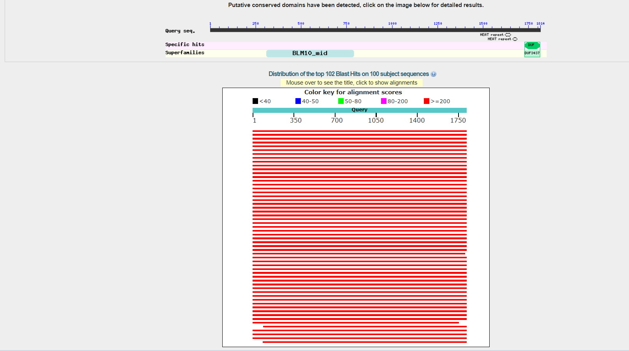

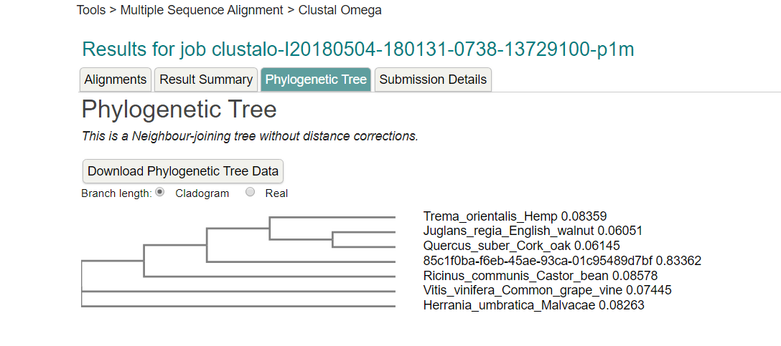

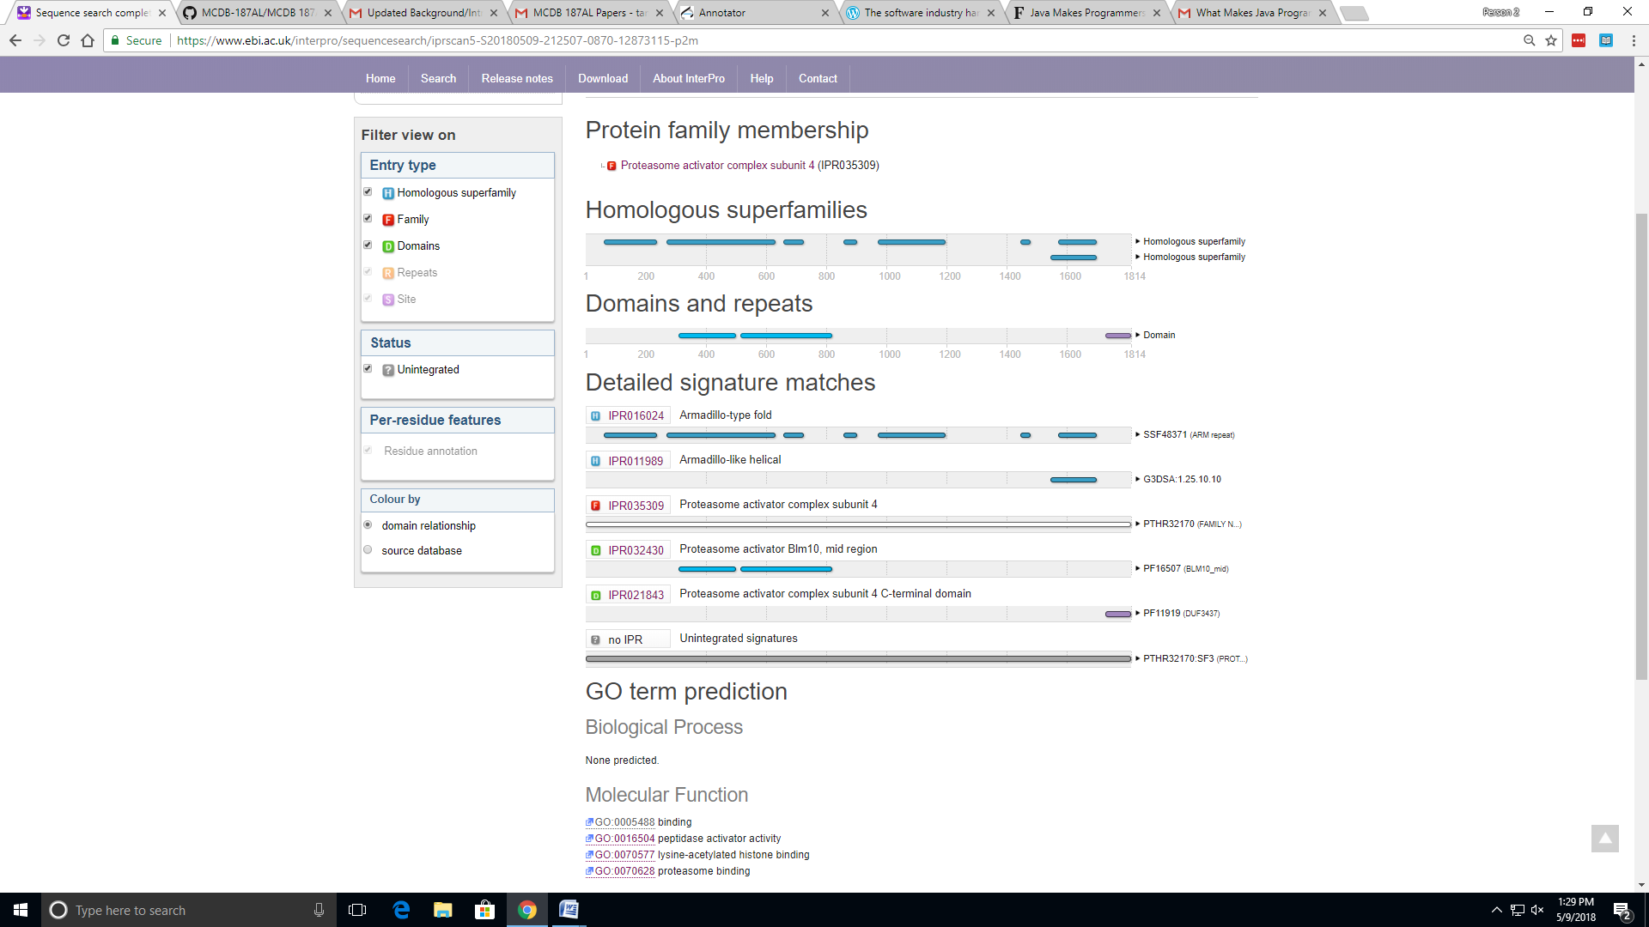

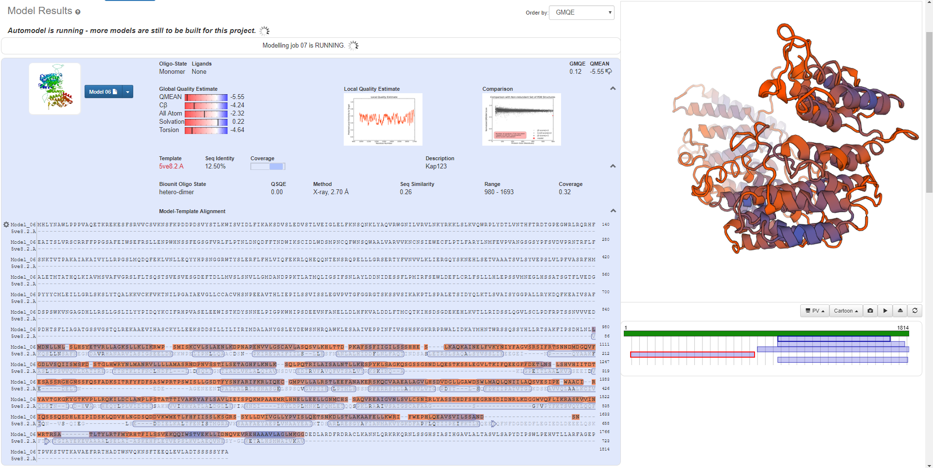

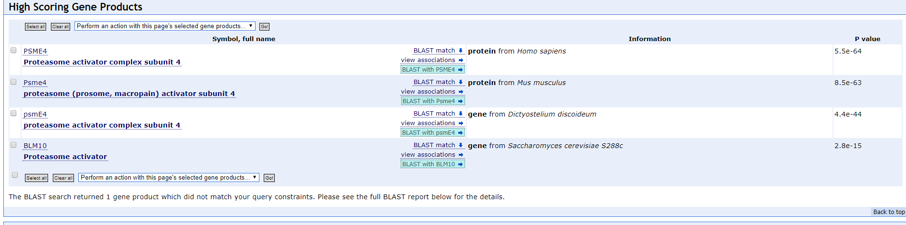

Chr8730000

MEGTSTTVPFKNLHSREYQGHKKKVHS

VAWNCTGTKLASGSVDQTARLWHIEPHGHGKVKDIELKGHTDSVDQLCWDPKHGDLIATA

SGDKTVRLWDARSGKCSMQTELSGENINITYKPDGTHIAVGNRDDELTILDVRKFKPMHK

RKFSYEVNEIAWNMTGEMFFLTTGNGTVEVLAYPSLRPLDTLVAHTAGCYCIAIDPMGRY

FAVGSADSLVSLWEISEMLCVRTFTKLEWPVRTISFNYTGDYIASASEDLFIDISNVHTG

RTVHQIPCRAAMNSVEWNPKYNLLAYAGDDKNKYQADEGVFRIFGFESP

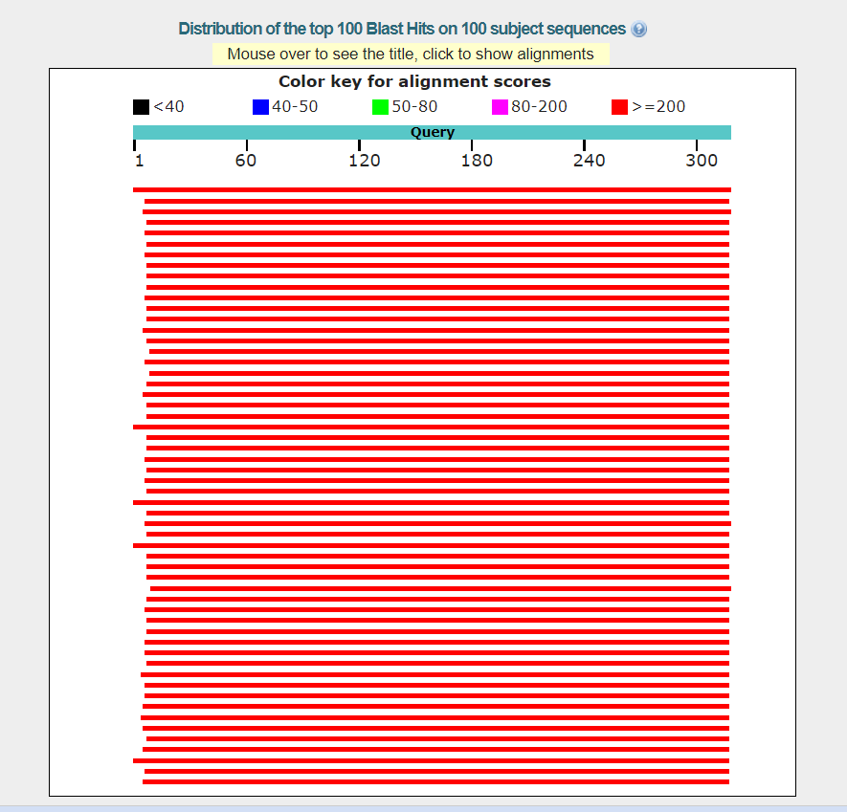

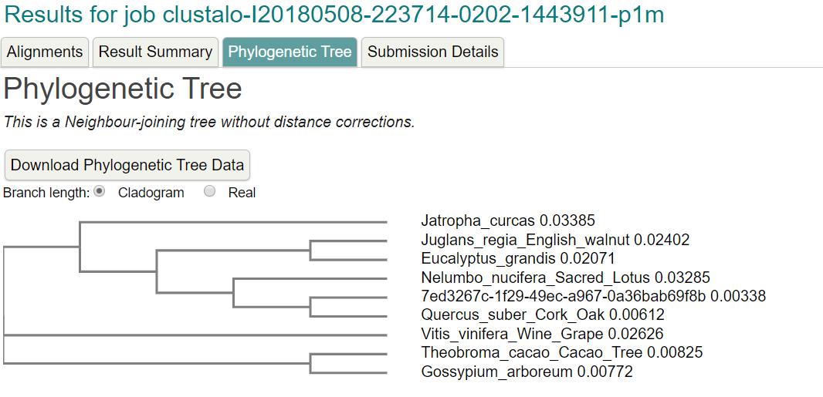

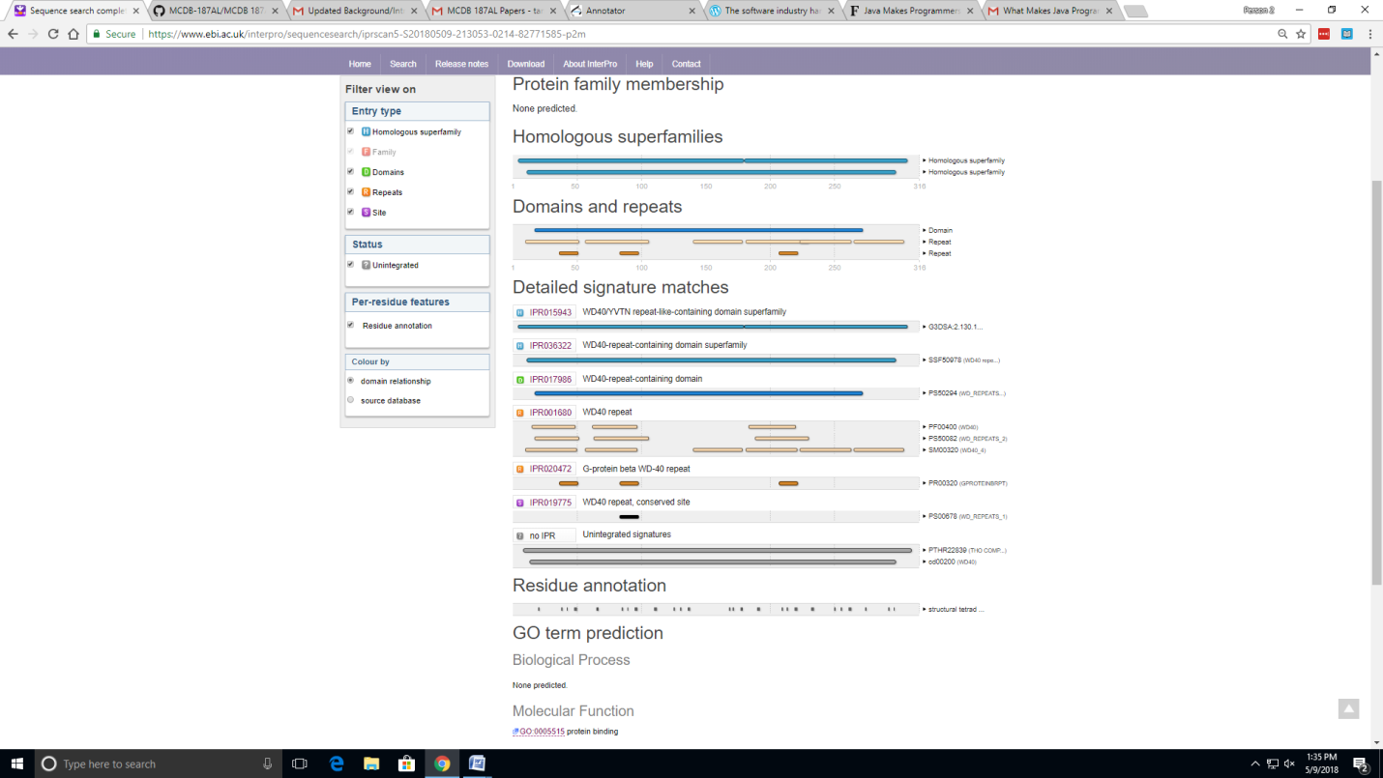

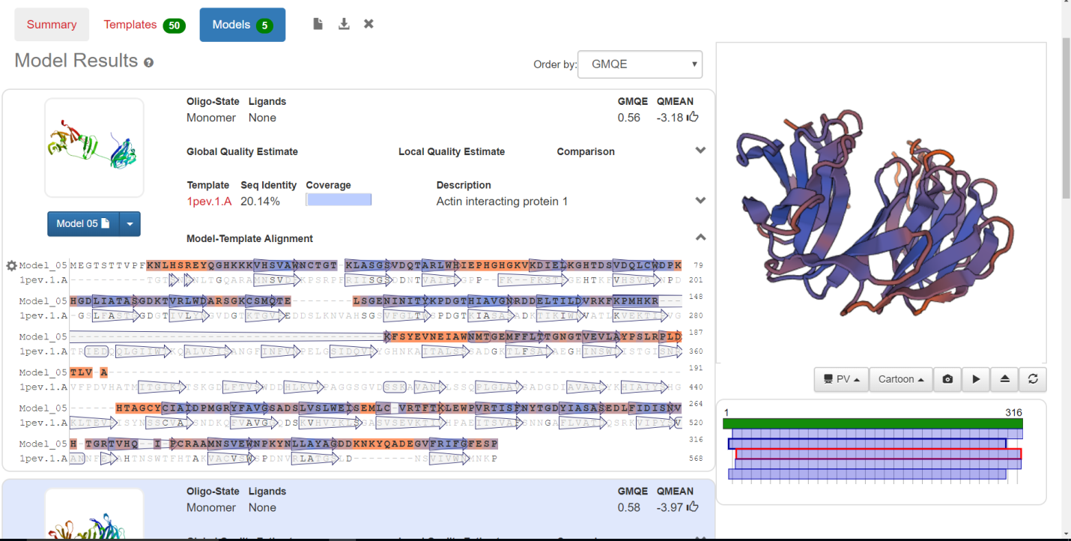

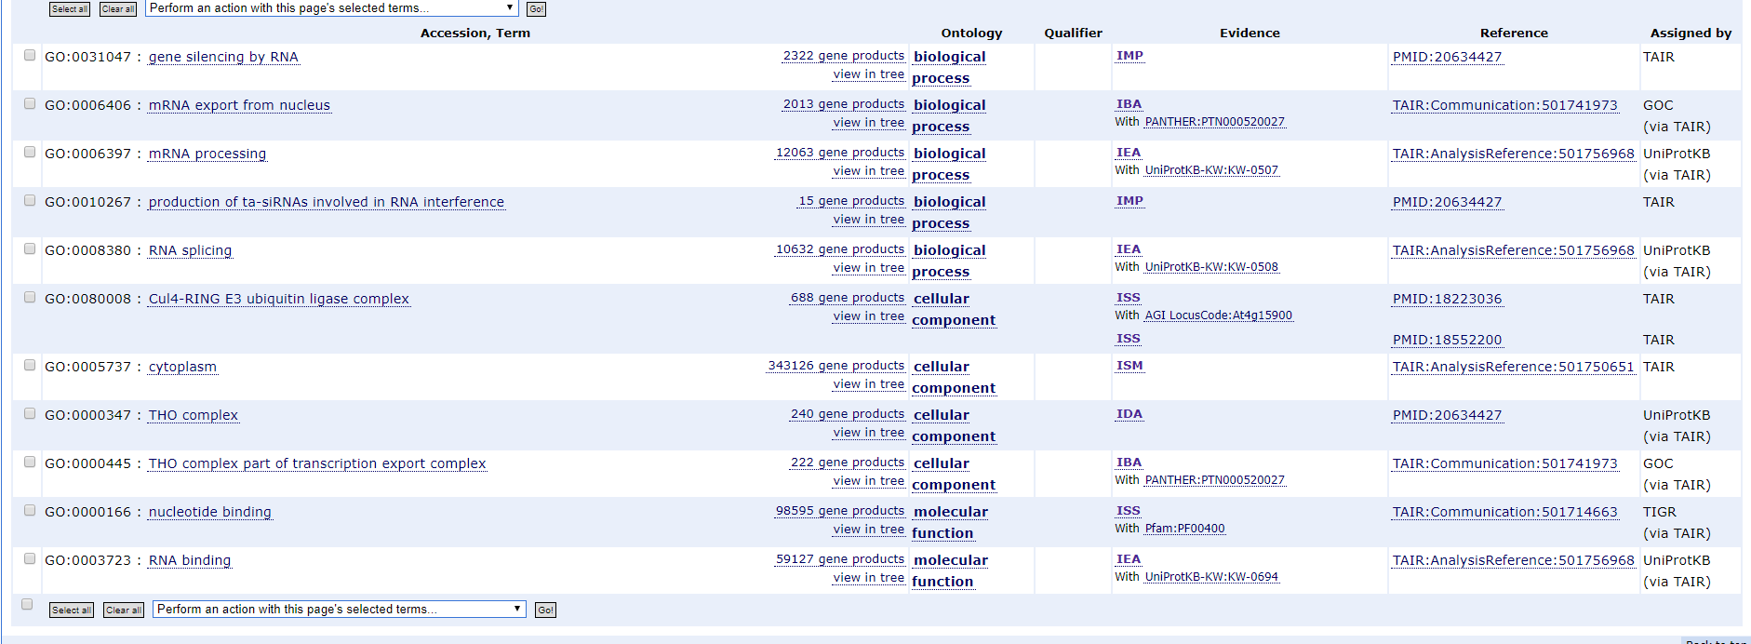

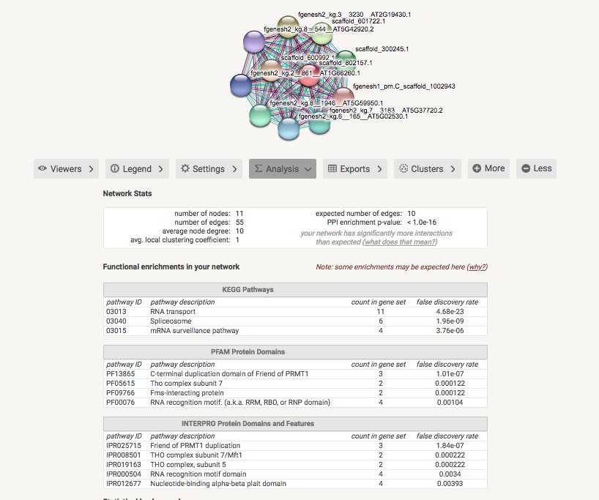

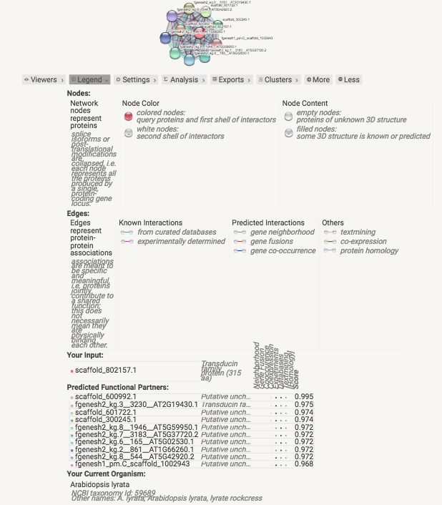

**Chr8** 717500

>c84d065a-5d5e-4393-9847-45b4e0fe0d61 (sequence:mRNA) 302 residues [chr8:716664-724153 - strand] [peptide]

MASSVGGAARYMAYSPSPSAPPSPHLSGLRSAAAAAAASSAAALLDQEKYLTELLAERHKLSPFMPVLPN

CYRLINQEILRVTTLLGNASVLGQSGLEHASPLASGGIFSNGGADVNGWASRFQSEMSGLIQPSSAQNWL

SSQCSSSGLIVKRTLRVDIPVEKYPNYNFVGRLLGPRGNSLKRVEASTECRVLIRGRGSIKDPTREEMMR

GKPGYEHLNEPLHILVEAELPVEIIDARLMQAREILEDLLKPVDETHDFYKKQQLRELAMINGTLREEGS

PMSGSVSPFHNSLGMKRAKTRG

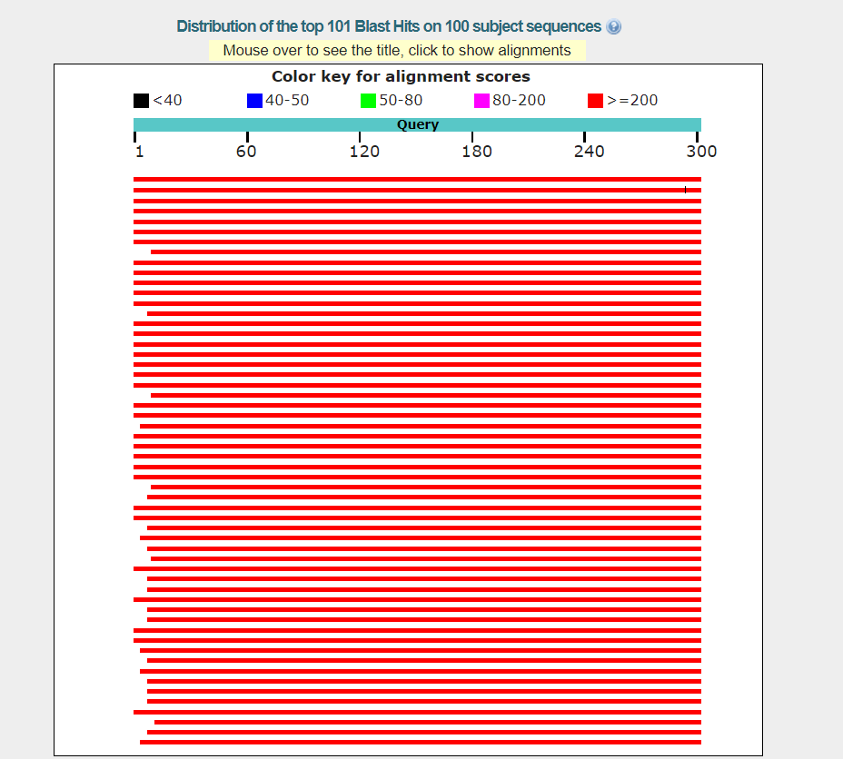

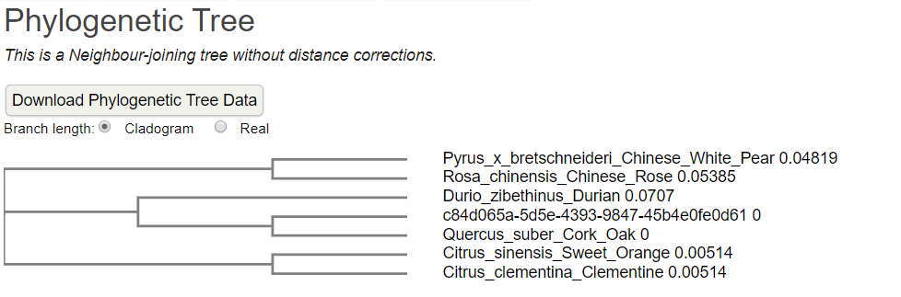

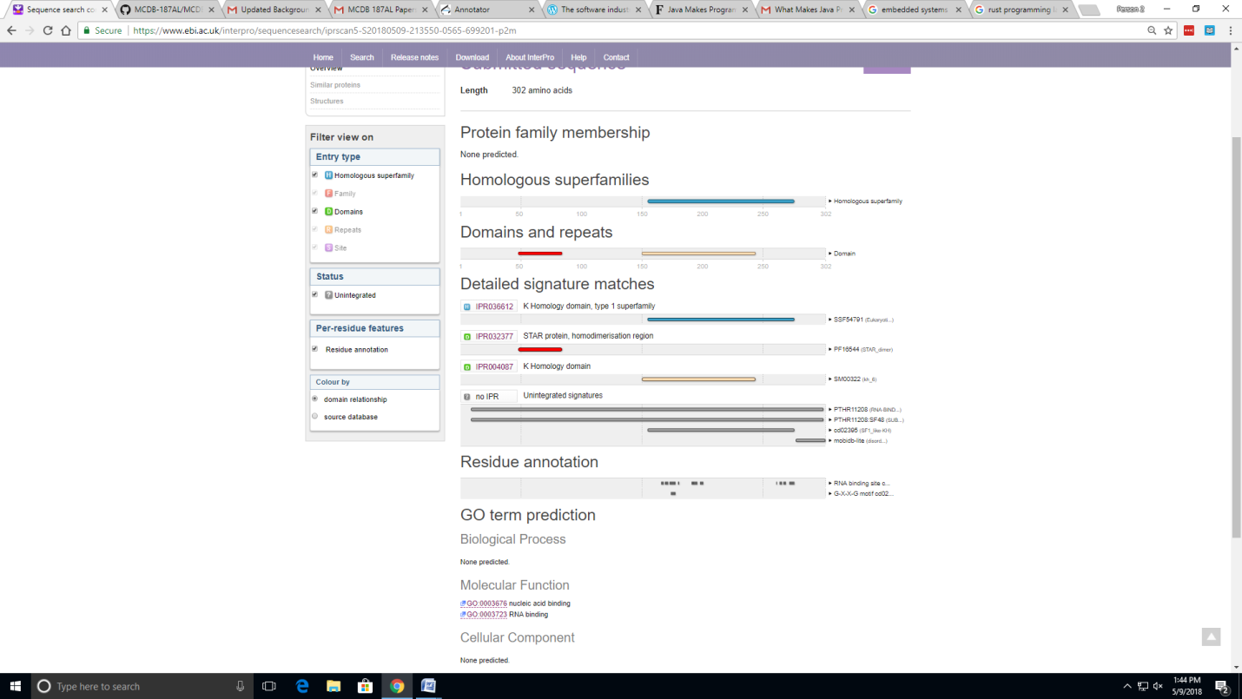

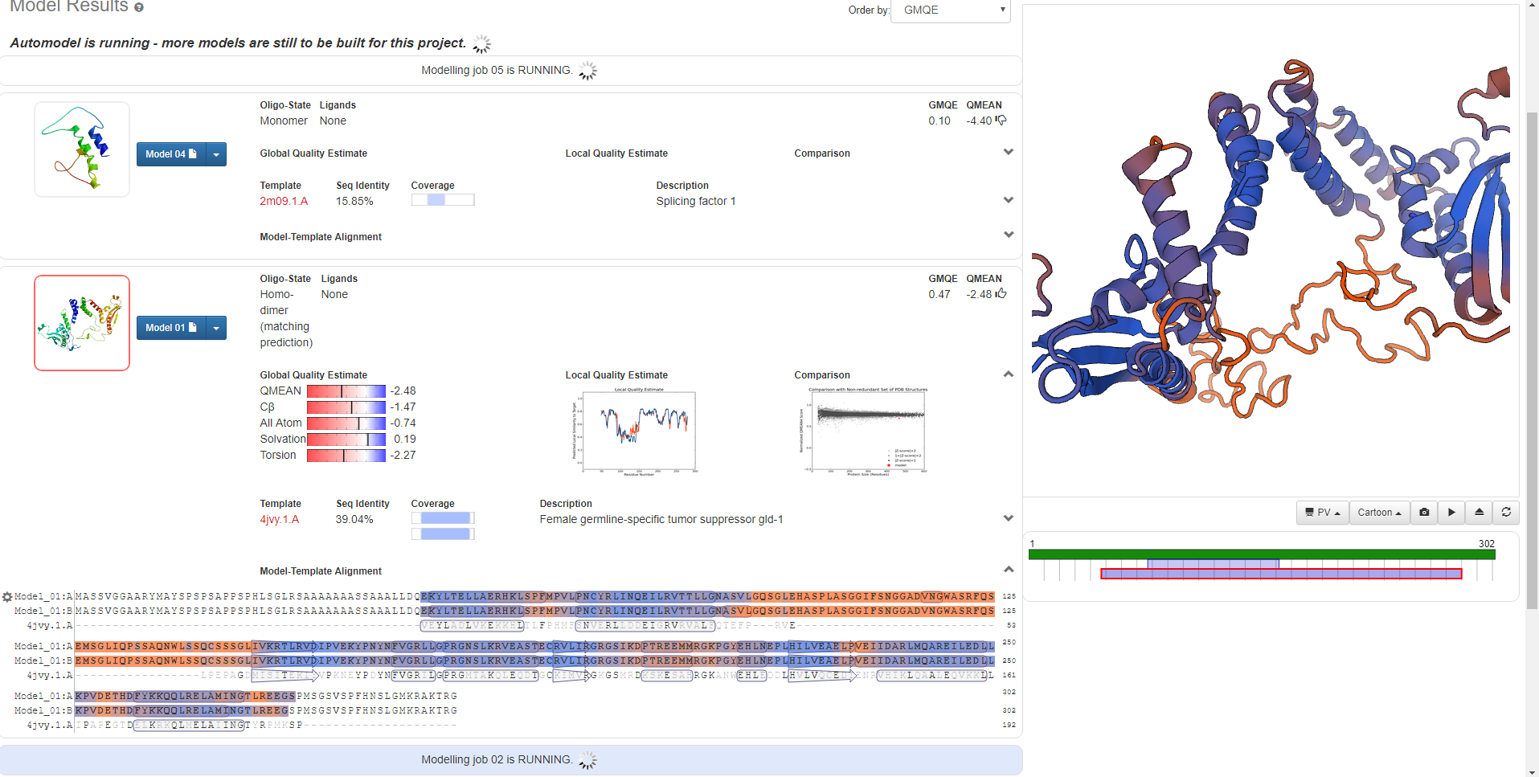

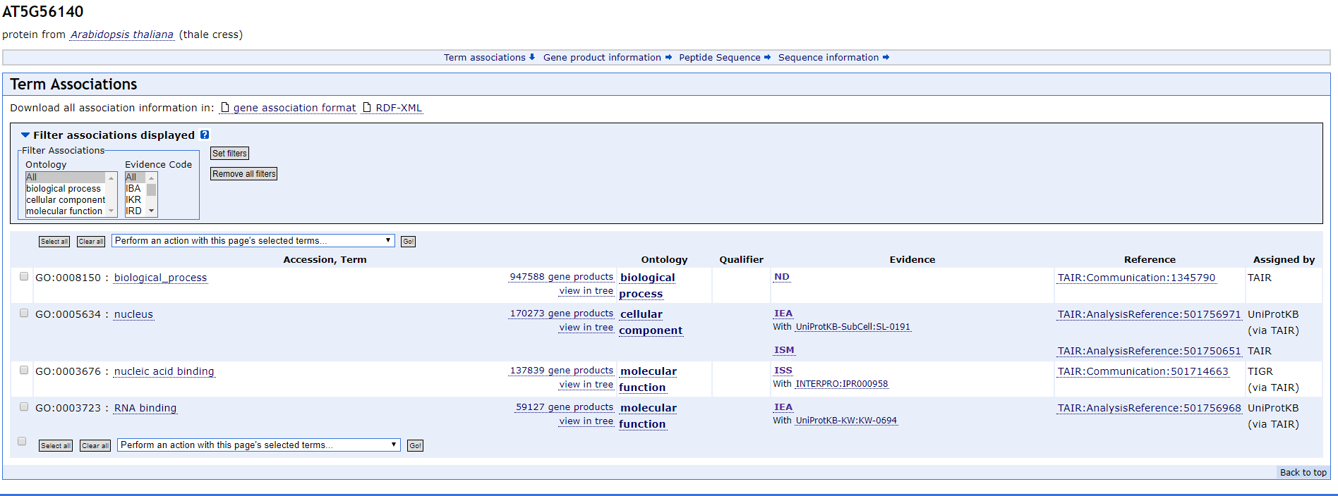

Chr8 711250

>8221e23d-7354-4588-b279-b93bc84e6ad3 (sequence:mRNA) 230 residues [chr8:711214-715487 + strand] [peptide]

MGNKVGKSESPKKVSKPETKLEAKTVEAMKRRAAAGTSMKSFNSIILKFPKIDESLRNCKVIFKQFDEDS

NGAIDYEELKKSFHKLEISCTEEEINDLFQACDINEDKGIDFNEFIVLLCLVYLLKDDAATLHAKARVGM

PDLEATFETLVDAFVFLDKNKDGYVSKSEMVQAINETTSGEGSGQIAMKRFEEMDWDKNGMVNFKEFLFA

FTGWVGIDDNEDEEEGGEKV



